

Bank of England

Inflation Report

August 1995

Inflation Report

August 1995

Recent dcx clopnients in inflati‹in

Retail prices

1.2 Producer output prices

.3 Expenditure deflators Other measures of inflation Summary

1. Nlonev and interest rates
   1. Money and credit

Broad money

re

Banking system

a money Narrow money

|  |  |
| --- | --- |
| 2.2 Interest rates and exchange rates | 16 |
| 2.3 Summary | 18 |
| *Broad mone y anal the ’Glaxo effecf* | *10* |
| Demand and supply | 20 |
| Total demand | 20 |
| 3.2 Domestic demand | 20 |
| Personal sector demand | 20 |
| Housing market | 22 |
| Corporate sector demand | 23 |
| Stockbuilding | 25 |
| Public sector demand | 25 |
| Net external trade | 25 |
|  | 27 |
| 3.5 | 30 |

*Stock cycles*

*The UK chemical industry 29*

The laliour market Earnings

|  |  |  |
| --- | --- | --- |
| 4.2 | Labour demand |  |
|  | loym | 36 |
| 4.5 | Unemployment and wages  Price and wage expectations | 37 |
| 4.6 | Productivity and unit wage costs | 39 |
|  | Summary | 39 |
|  | External influences |  |
|  | The exchange rate and impon prices | 40 |
|  | The pass-through of higher import |  |
|  | prices to retail prices | 43 |
| 5.2 | Profitability |  |

MilrlUfacturing Retailing Utilities

Summary

Prospects ft›r inflatitin 49

The economic news 49

* 1. The current economic conjuncture
  2. The Banh’s medium-term projection ñ2
  3. Outside inflation expectations 53
  4. Conclusions

Symbols and other information

Except where otherwise st:ited, the source for the data used in charts and rabies is the Central Siatisiical Oft‘ice.

not avaiLtble.

nil or less than half the final digit shown.

Because of rounding, the sum of the separate items may sometimes differ from the total shown.

On the horizontal axes of graphs, larger ticks denote the first obsei vation within the relevant period, eg dnta for the first quarter of the year.

Email: dh95 Dcityscape.eo.uk

The Summary of this *Reyort* is available at: [http://www.coi.gov.uk/coi/depts/GBE/GBE,html](http://www.coi.gov.uk/coi/depts/GBE/GBE%2Chtml)

Printed by Park Communications Lld B Bank of England 1995

ISBN 1 85730 058 0

SSN 353—6737

Summary

Twelve-month RPI and RPIX inflation rates have declined slightly since. the May *Report.* Twelve-month RPIY inflation has continued its gradual climb upwards. These measures of inflation are likely to increase over the summer. Domestically generated inflation has been much weaker than retail price inflation.

Narrow money (measured by notes and coin), broad money and credit have all grown strongly. The exchange rate is slightly lower than at the time of the May *Repurt.* Bond yields suggest sterling is expected to fall a little further over the next ten years.

Expectations of inflation in five and ten years’ time have

increased, but they have fallen for shorter horizons.

Most activity indicators have been weak since the May *Report.* But non-oil **GDP** expanded at a rate a little abo,ve trend in the second quarter, as the output of services more than made up for the weakness of industrial production. The main danger is a downturn due to destocking. Trade performance was strong in the first quarter, and the outlook continues to be good, because of the lower real exchange rate. The growth rate of the demand for labour fell in the first half of this year. There are still very few .indications of upward pressure on wages. Price.pressures at the early stages of the supply chain have increased, largely as a result of higher prices for imports. The pattern of a ‘dual economy’, with sharply contrasting fortunes in the tradable and non-tradable sectors, remains marked.

The Bank’s central projection for inflation two years ahead is similar to that in May. It remains the case that it is more likely than not that RPIX inflation will be above 2'/i% in the middle of 1997.

**The** Oual **nature of the economic recovery makes the.dilemma for monetary policy more acute than before. Time will resolve** tliq.1puzzlesiati,out..the strength.in activity, money growth and. **domestic inflation. But the:lags between changes in monetary**



#### interest:rated haviRg to go higher tliañ. would otherivise fie the.







# 1 Ret ce

Headline measures of inflation have fallen slightly since the time of the May *Inflation Report—once* the published data are adjusted for the Central Statistical Offfce’s (CSO’s) error in calculating retail prices in March, April and May.( Retail price inflation was 3.5&o in June, down from 3.6% in March. The Government's target measure of inflation, the

twelve-month rise in the retail prices index eKcluding mortgage interest payments (RPIX), was 2.8% in June, compared with 2.9% in March.

I99." 93' 94 95



'Table l.A

Short-run measures **of inflation**





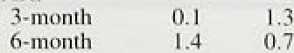



The RPIY measure of underlying inflation—which excludes indirect taxes—has, however, continued to edge up. It was 2.3% in June, compared with 2.2% in May, 2.1 % in April and 2.0% in March (see Chart 1.1).

Shorter-run measures of inflation can provide a better insight into more recent price developments, provided they are accurately adjusted for seasonal patterns and changes in the timing of tax changes. Table l.A uses a rough-and-ready method to adjust RPI and RPIX for seasonal effects, but not tax changes; the latter do not

.follow a fixed seasonal pattern because of the change in the timing of the Budget. It shows that shori-run measures of headline inflation fell between March and June, as the effect of tax increases around the Christmas period dropped out of the calculation. Seasonally a‹ijusted RPIY inflation, which was the measure least affected by the change in the date of the annual Budget from April to November, has, in the past, given the best guide.to the underlying trend; it also declined.

The .goods and services covered. in the RPIY measure

:can be separated into two major categories—those goods

,and services which are commonly traded internationally, afid.those. which are not. As seen in Chart 1.2, tradables 'i;nfiation reached a low **point—virtually** zero-in





reach 2.4% in June 1995; in March, it was above the inflation rate in the non-tradables sector for the first time since the data were fii’st available in 1988.

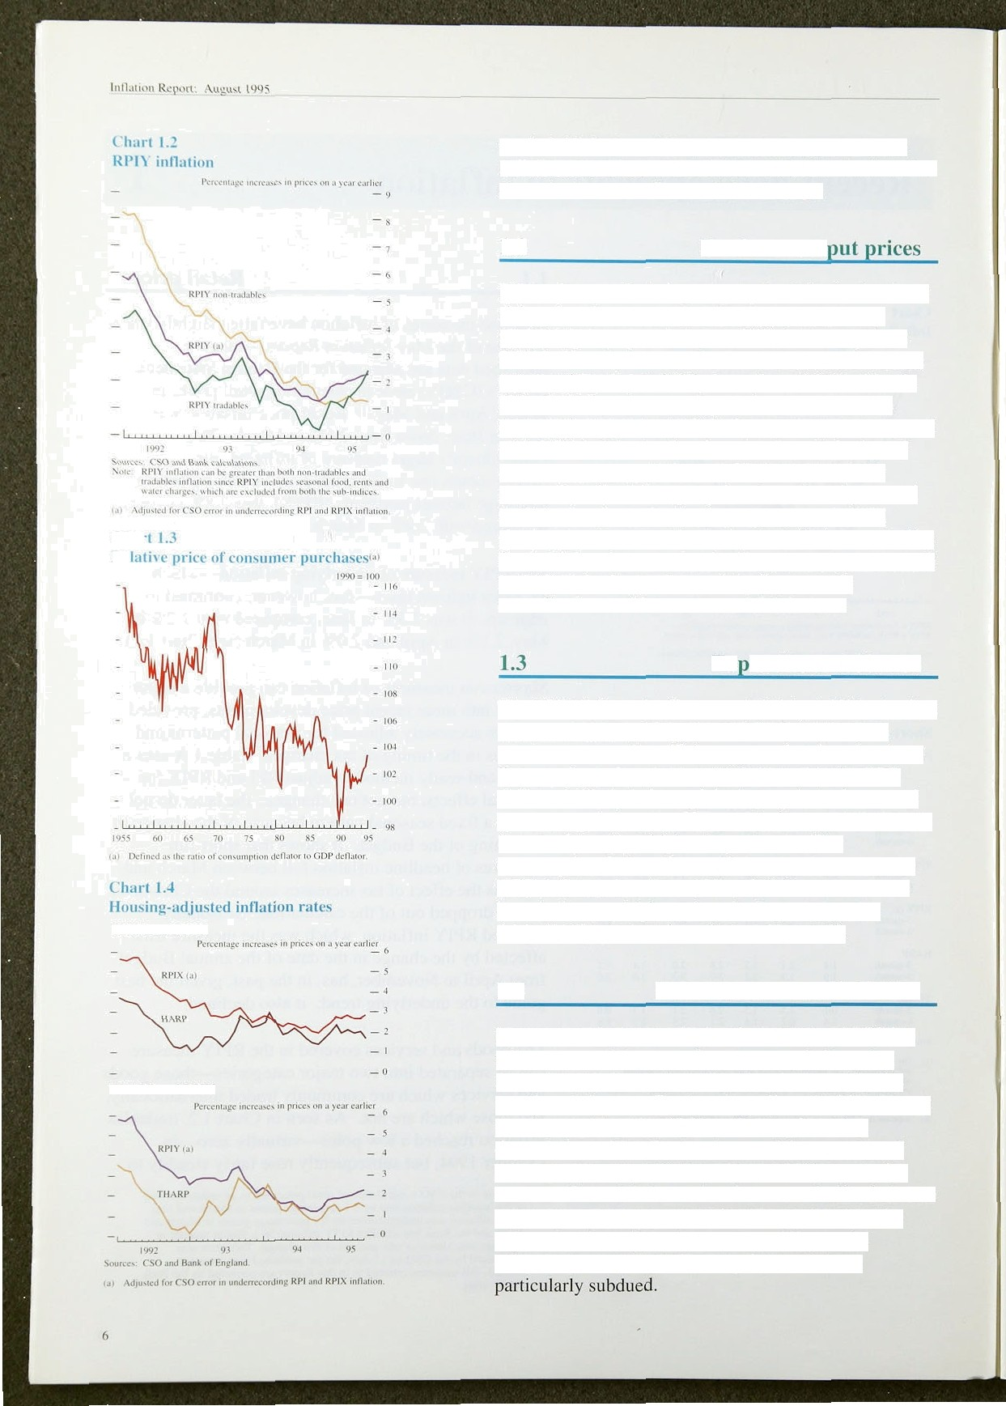

( frs

H›tRP and RPIX

THA RP and RPI ¥’

## 1.2 Producer out

Dtimestic rnanuf’actiiring output price inflation has been rising since last summer. Output price inflation in inanufactui‘ing as a whole was 4.29r in Juns, up from 3.8Uc in Mai ch; but on a three-month annualised basis, output pi‘ices rose ut 3.5%, down from 5.OF in March. It’ food, di ink, tobacco and petroleum are excluded, tiritput prices rose by 4.8% in the year to June, compai‘ed with 3.9Uc in March. But there has been little sign of any recent pick-up in the monthly rate of increase: seasonally adjusted output prices have risen by around 0.4% in every month since July 1994. As u result, shoi‘ter-run measures of output price inflation, excluding tood, di’ink, tobacco and petroleum. have remained close to 5.0% since September, and the three-month annualized rate of increase was 4.9% in June.

## Ex enditure def’lators

The GDP deflator (at factor cost) fell by 0.1% in the first quarter of 1995 and was up only 0.7% on the same quarter a year earlier. This suggests that there has been little domestically generated inflation. But the **GDP** deflator is likely to have picked up again in the second quarter. as prices set by UK producers and retailers were increased to reflect higher import costs. The consumption deflator has tended to rise faster than the **GDP** deflator since the middle of 1990, as consumers have had to pay higher prices for imports than for domestically produced goods (see Chart 1.3).

### Other measures of inflation

Measures of inflation which adjust RPIX and **RPIY** to take account of the cost of owner-occupied housing suggest that inflation is weaker than indicated by the unadjusted figures. The housing-adjusted **RPIX** (HARP) measure replaces the CSO's estimate of housing depreciation with a Bank estimate of the user-cost of housing. The THARP index adjusts **RPIY** in a similar manner. Chart 1.4 shows that the recent decline in house prices has opened up a considerable gap between the adjusted and unadjusted measures, adding to the evidence that domestically-set prices have been



**'Chart IJ''**

**Distribution og pride changes‹°›.**



**Alternative** measures,of **inflation**

Peice'ninlr chan8es in 'prim on z year earlicr

Trimmed meon.





Although the RPIX and RPIY measures of inflation provide insight into the ‘underlying 5 rate of inflation by excluding changes in.mortgage interest payments and indirect taxes, they include prices which are particularly volatile or which change by large amounts at irregular intervals. Such price movements can obscure the underlying picture. Two measures of inflation which attempt to correct for this volatility are the median and the trimmed-mean rates. The median inflation measure uses all the component series of RPIY each month to compute a median twelve-month inflation rate; the trimmed mean excludes the largest and smallest 15% of price changes over the year. Chart 1.5 shows the distribution of price changes in June 1995; it illustrates that the distribution is skewed upwards. Despite this bias, Chart 1.6 shows that the trimmed mean inflation rate has not diverged significantly from the RPIY inflation rate in recent months. The median inflation rate has been much more volatile; it was lower than RPIY inflation throughout 1994, but has since picked up.

Over the next few months, RPIX and RPIY inflation are



###### likely to edge up, reflecting both smaller discounting in

, the summer sales this year than last and higher import prices feeding through to retail prices (see Chart 1.7).

## 1 5 S a

Twelve-month RPI and RPIX inflation rates have declined slightly since the May *Report—when* adjusted for the CSO’s error. Twelve-month RPIY inflation has continued its gradual climb upwards. These measures of inflation are likely to increase over the summer.



Most shorter-run measures of inflation have fallen sharply since the time of the May Report—even if ihdirect taxes are excluded. Domestically generated inflation has been much weaker than retail price inflation and short-run measures of inflation which adjust for housing costs have fallen.

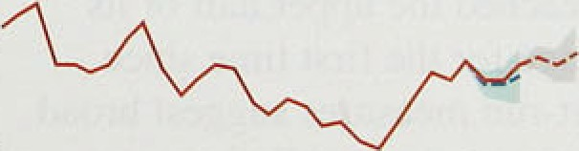

.2

'I’ulilc 2..t



## dond e ed t

Broad money has accelerated since the May *Report,* and its twelve-month growth .rate has rislen into the upper

t* ross **th rules ol’** monetary **apgregaies‹**







7.H

5>

6.3

Cl(}

Mnr.

I .J

IU..J

7.g

fi.4

Ayr. U.4 | I). I g.5 5.4



6:3

6.ñ

Apr. 0.7 III-fi 10.U

half of its 3&•—9% monitoring range. Credit has continued to pick up sharply (see Table 2.A).

Money can be used both as a.store of value an‹i1as.a means of payment. .Increases in broad money presage inflation if they:signal rising nominal spending: I:n the short run, however, the implications of an increase in broad money are less clear. An acceleration in M4 could reflect either an acceleration of planned spending, or—since other financial assets excluded from M4 are close substitutes for bank and building society

May 0.¥ TI.ñ 9.8

June \T.2 7.* 8.3

B.0

deposits—no more than a reshuffling of funds between







ih i Annuali 0.

199a Q3 1994 Q4 1995 Q 1 1995 Q2





assets, with no particular implications for inflation. Even though the acceleration in M4 must have been consistent with changes in rates .of return .on different financial assets and liabilities, it is nevertheless important to .understand and those rates of return have changed. The 1980s experience of financial liberalisation demon5trated how banks could generate liquidity if they thought that lending opportunities.had improved, and la shift in rates of return in favour of bank deposits may itself beta.precursor of more.buoyant corporate activity, financed in part by bank lending:

There, are three main facts to consider: the acceleration in deposits, the acceleration in credit and the behaviour of the banking system.



*Broad money*

Broad .money, M4, grew by 6.7:&r in the year to June, compared **witli 5.4 ifi** tire year'to March. I* May, broad moneys.grqwth reached’the .upper’hal.f of:its

.3&-9% .monitoring.range for the first time stnce . September 159.1. Short-run measures suggest Sroad money has been increasing more rapidly in tecent months. However, its behaviour has’been harder to interpret since Glaxo's.take-oder of We1lcoyie.at the end of March,. which inflated’both.6t4 0cposits'and baak and building society lending, In parucular, the fact tiiat the





*Mone›' and interest rate.s*

Chart 2.1

Growth rates of M4 depoails



D8O 61 83’.8j #4 B5 66 87’’88 &9’’.9O 91 92 03 94O5



take-over occurred at the end of the month meant that Glaxo and WeJlcome shareholders had insufficient time to rebalance their portfolios before the end-March data were collected. As a result, the March money data were artificially high. The box on page 10 suggests that Wellcome shareholders are likely to have adjusted their portfolios relatively quickly, however, and that there is little reason to exclude the deposits from the Glaxo

take-over from the April and May M4 data. M4 grew at an annualised rate of 11.3&o in the three months to May,

" the strongest growth recorded since November 1990 and

« more than double that recorded towards the end of 1994.

A better guide to the growth of broad money in June is " probably the four-month annualised rate, as it excluded

> the end-March data; this showed that M4 increased at 10.4%.

Empirical evidence suggests that the characteristics of the demand for both money and credit vary according to the type of economic agent, so it is useful to split the aggregate M4 and bank and building society lending data by sector. Chart 2.1 shows that the growth of M4 deposits by other financial institutions (OFIs) has been rising since the end of 1992, but until recently this has been offset by weak deposit growth by the personal sector and by industrial and commercial companies.

Consider the personal sector. The short-run growth rate of personal sector deposits has been increasing steadily over the past year and they picked up by £5.2 billion in 1995 Q2, accounting for around half the total increase in M4 deposits. However, the increase in personal sector deposits in the first quarter was boosted by a fi3.3 billion contribution from unincorporated businesses—largely as a result .of the payments to Wellcome shareholders—so individuals' deposits give a better guide to the underlying trend. These have accelerated over the past year and rose by a further £6 billion (l.8Ro) in

1995 Q2—a three-month annualised rate of 7.2%. (They would have risen even faster had it not been for the fact that the data were collected on a Friday, after people had withdrawn money from deposit accounts for the weekend period.)

##### The relative stability of the growth in personal sector

..deposits.in the past suggests that the recent acceleration should give added cause for concern, as it may anticipate an acceleration in planned spending: But there.. are other reasoii3.why..deposits may.have increased: A one-off







Broad money. and the ‘Glaxo effect’

Broad inoney plays a ke:y role .iri the mo;fietâry. tr5nsinission process„ ivith an a.cceleration iii ñroatl. money leading, other things béiing equal. to an

w‹iuld tend to reallocate their ortfolio holdin s re)attvely! quickly.

incrensé in the growth of nominaldomestic demand. Other eviderice supp9rts this interpretation.

’

The recent acceler*tion.in broad:money has.takeri place, .however, at the .same.time as Glaio’s take-over

'Whol'esale deposits.fell.Strongly 'ie the middle of. April. hich rñay. have'reflectéd:.tire.ten-.day.

of Wellcome inflated both sides ofi bariks’ balance ”settlement.period.for shares bought shortly.afteir the sheets by £5'/• billiori: So should the ‘Glaxo effect’ be Glaxo!take-over!.by forr;ier Welledrrle! shareholders. stripped out of the calculation of ñroad **money !And** retail deposits r0se by 23.2.!billion an April— growth? double the **average increase** over tñe preceding-six

months—which c1oii1‹i:.reflect Wellcome shareholders

Not .riecessarily. Although Wellcome shareholders paid their.proceeds .from the fake-over into bank accounts on 31 March, distorting the March data,. there is .no reason .to suppose that they did not

reinyesti:rig funds: in smaller paékets:of.:shares, w.ith.small shareholders..who sold the:shares.placing thei.r proceeds on.:deposit.

subsequently reshuffle their portfol.toe fairly quickly. In addition, forriier Wellcome shâreiiolders niay have

bought more overSe3s, sécurifies. The ñaia show’.that The table below presents the flows of retail deposits— sterling deposits!.helfi. by **overseas** mon-banks i'ncreased. which tend to be made by smaller investor.s and by £2.3 billion. i.n April, a. month.in which thdy also wholesale deposits—which tend to be made by larger repaid £0.5 billion of..net sterling.:debt,. suggesting that investors—to banks and building societies in recent sterling may have been.paid to:foreign shareiiolders. i!n months. It shows that wholesale bank and building exchan.•e for oversieas securities.

society deposits increased by £5.9 billion in March,

before being reduced by £1.1 billion in April. This The fact that most of the. shareholder money may.ttave suggesis thai most of the money paid by Glaxo to been unwound by the end of May; or was voluqtarily! Wellcome shareholders was placed on wholesale retained in retail deposits, suggests. tliat.there is l:ittle deposit at the end of March. And given thai wholesale cause for excluding the‘ impact of’the Glaxo take-oyer dejiosits had risen by an average of more than from the end-May M4 data. Nos ill June M4

Sl billion.a month in the preceding three months, it is deposits have! been‹affecféd; however„ the.shorter-run likely that.a significant proportion of the additional growth. rate which compares the level. i.n Jufie with tliat: wholesale deposits were run down, i.n April—w,ith in March will, of course, be.distorted.by the

some pfi them. being lodged as retai.l deposits. artificially:.high figure recorded for March. .So fpy

— — June,the four-.moiitft annualised rate is’ probably a better rñéasiiré of short-'run groâtliithan ’the

.tEree-month arinua:l!ised:.rate: .

" On the other side of the ñal;uice street the arguments:



.for ineeluufi::iinng.or excludi!n



sterling bank lending resulti!ng froñ .the Glaxo take-over are..l.ess.clear: According to.one interpretation;.some.of.the lending;was transitional that is, money was.borrowed.frown banks as.a.

ternpo.raiy measure uriti!. laxo hid tinny to wsoucture The..increase iri wholesale deposits iñ May cannot be iis liabilities. There 4s evi‹ience that this is it least explained ñy.the.Glaxo::take-9ver; .if'anytfii:ng,. i.f partly ture:: G:laxo issued bonds to the value otjust

.G e!.of !he fermer W.h11 o Je:d harebgoId"ers.: w’iith

.nderg£1 .bi‘ll’ton4n.th**e..se**

d buartg **,.sngg** n:ng.that

axo,payments.,on. w o esa e: eposits were strll it was versifylng.away : m . qn . . w rig..

adyusung,.this would.have depressed the:net.increase:. However, muchl.of:the mcmase4n lenthng probably This is.circumstantial:.evidence that.the: Glaxo money riprisented an increase.in plarined bank bñiro tag: had:already been unwourid—or had been vo.1uritarily. and jot.a di uilibri.um This.Ruperts.that tlie lefi on:deposit. And; indeed,.this:is: what one:woa1‹i Gtmo•relâted ionicmaeain.editshauld‹not be

expect..given that around four, filths.of Welleome excluded the data,Ntkojigh die Interpretation of shares Were held..by,laige instituhonal‘.inveitors, whQ the , moray ba su1y.for4ole fitba,



Chart 2.2

**Personal sector financial assets at** the end

0f 1995 QJ



: iasirurricnis I .2& 3.OF

“ Other













Chart 2.3

Corporate sector financial assets at the

end.:of 1995 Q1





the housing market, or a 'windfall gain’ from the 2% rise in real personal disposable income in 1995 QI (see Section 3). It could also be a response to rates of return on bank deposits: in 1995 Q2, around 70% of total

deposits were held by individuals and unincorporated businesses, suggesting there were considerable funds at the personal sector's disposal (see Chart 2.2). The key rate of return facing the persona) sector is the interest rate on short-term deposits. which is linked to the official base rate: an increase in UK base rates increases the relative attractiveness of deposits in the short run.

Deposits from industrial and commercial companies

(ICCs) have been more subdued. They rose by

£325 million (0.4%) in the first quarter—they would have declined had it not been for the Glaxo take-over of Wellcome; in the second quarter. deposits fell by

£375 million. Although ICCs’ deposits constitute less than 15% of total bank .and building society deposits, they are much more volatile than the personal sector’s share, because large firms find it easier and cheaper than the personal sector to switch between assets. In particular, the corporate sector holds a greater proportion of its assets than does the personal sector in the form of bonds and short-term market instruments—such as Treasury bills, commercial paper and CDs (see



Chart 2.3). Despite the volatility of ICCs’ deposits. it is clear from Chart 2.1 .that their growth has been relatively subdued over the past four years; Bank research has shown that reductions in ICCs’ deposits have in the past

been associated with lower planned investmen},tI)

Increases in deposits from other financial institutions (OFIs) have been particularly large recently, but they have fluctuated sharply in the past. The growth of OFIs’ deposits fell from a peak of over 50% *u* year in the



mid-1980s, and deposits fell in absolute terms in 1991; deposits from OFIs have slnce picked up and increased at an annual rate of 15.2% in 1995 Q2, more than double the rate recorded towards the end of last year. There is lfttle reason to suppose that an increase in OF1s5 deposits

represents afl increase in their planned nominal spending, as the financial sector*s holdings of assets depend largely ori:relative rates of return.



**Cradit**

:Baak arid: balding.society lending has also increased

**..rapi;ily..** Cpmparing Ju:ne with February—the month

befoie‘the Gla›io take-over—it rose it a four-month









**thart 2.J**

tiriru th rtites of credit* '



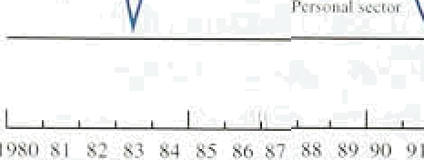



Chart 2.*

**"1’olal** quarterly sterling financing by ICCs'•'

T url. of »'hich:

Nei i.our* nd skrl ing c my mere ill paper





annualised rate of 9.3ho. The.acceleration in credit since November has been driven by strong corporate sector borrowing. Despite the fact that the corporate sector accounts for only one third of all credit advanced by banks and building societies, the.pick-up in **ICCs'** and OFIs’ borrowing has more, than compensated .for the moderate growth of personal sector borrowing. This contrast between strong corporate .demand for funds, and subdued personal sector demand mirrors the ‘dual economy’ described in Sections 3 and 5.

Lending to the personal sector by banks and building societies has been relatively subdued. It increased ñy

£6.2 billion (1.4%) in 1995 Q2eto stand at £440 billion. This compares with an increase of £6.8 billion (1.6%) in 1995 Q1. Chart 2.4 shows that, .despite the slowdown in 1995 Q2, the growth of personal sector borrowing has been increasing since the middle.of 1.993—although it is still much lower than in the late 1S80s. Within .the personal sector, individuals account for aroun‹i 90% .of borrowing, and unincorporated businesses for the rest. Borrowing for house purchase (or secured against housing)—which accounts fot around 90&r of individuals’ borrowing—rose by £4.4.billion in

1995 .Q2, compared with £4.8 billion in the first quarter: it stood at £355.2 billion .in June. Consumer credit remained at a high level in the second quaner; it rose by

£1.3 billion, only slightly lower than the £1.5 billion increase seen in. the first quarter.

A broader measure of borrowing by the personal sector, including that from.specialist lenders, as well as from banks and building societies, .was also sabdued. Total net personal borrowin!g increased by £2..0 billion (0.ñ&) in June. The.three-month!annualised!.rate of i.ncrease fell

"’ • from 5..9&o in March. to 51.3%—the lowest.rate of

- i increase since September i993.,

##### Industrial and commercial companies have.sharply increased their:borrowing.’They Started.to increase.their net borrowing’in the fourth:quarter of 199.4=—afier the: first.rise:in base’rates in.Septeiiiber 1 94;. they had ni.n down theirdébt over the°previous !twq years. ICCs borrow.ed f2.4 bil1ion‘‘in the second quarter!iof.’1.9S5, compared with **J6:1.billion** in 1995 Ql. Buf.Glaxo borrowed aropnd £3'/i’bif1ion:at the end of March!and

 repaid.a signifi nt pYO Drtloo of that‘debt.in the second

quarter, so the hon-Glaxo, demand for funds %c.reased :

##### . slgfiifiCantly. ***Chart..2.5* shops** that **ICCs’** borrowi g has ndt been sttbstitutibg for other forms of ext rnfil '.financing. Bank research has sh.a n that, in the past,

12.

ozid inIeresy_rofes

Chart 2.6

Spreads on syndicated credits to UK conipaniest•i

- 140

##### higher ICCs’ borrowing has been linked with an increase in take-over activity.

###### Lending to OFis increased rapidly in the fourth. quarter of 1994 and the first quarter of 1995, and the

twelve-month growth rate more than doubled, from 6.7&• in 1994 Q3 to 14.09n in 1995 Q2. Some of the lending in 1995 Q1 was to securities dealers—a sector whose borrowing requirements are highly volatile—but there was negligible lending to securities dealers in the second quarter.





— — 20



Sour: Bank of£•ngland and.ICMP daiatosc.

law Intcms/iocaI.syridicac>J credits ‹o US lOCs and financial ins:ituTion*.:

Chart 2.7

Difference between wholesale and retait





- 3:5.





There is some evidence that over the past couple of years banks have become keener to lend money. One way of measuring competition for funds in the banking system is by examining bank spreads. Information on the spreads between loan and deposit rates offered to bank customers is not readily available. But Chart 2.6 shows one measure of loan spreads—the margin above Libor on syndicated loans to large UK corporate borrowers. Although spreads were volatile in the mid- 1980s, it is clear that they have narrowed recently. Of course, these are spreads on loans made by banks from a wide range of countries, not just the United Kingdom.

However, anecdotal evidence also suggests that bank margins have been squeezed recently. The June CBI Financial Services Survey noted, .for example, that margins had fallen further over the previous three months.

Banks have also attempted to attract more retail deposits—predominantly from the personal sector. Chart 2.7 shows the spread between wholesale deposit rates, which are approximated by the three-month

interbank rate, and average retail deposit rates- Over the past six months, as retail rates rose towards wholesale rates, the spread narrowed, after widening during the previous..year..

###### How can all these facts be explained? The evidence from the banking sector suggests that banks have become more willing to lend money—at least to large, creditworthy customers—and have reduced the price of

.banki.ng intemediation; at the same ti.me, the quantity of. credit advanced to the corporate sector has increased.

.The. mcr«aso in OFIS’ deposits at banks and building s‹miedes in the first quarter might be explained by banks

.bidding for wholesale deposits to .fund strong corporatel

bo ws



The implications for inflation will depend on whether the acceleration in credit will be sustained and how the deposits built up at banks and building societies over the past six months will .be used. Since OFIs tend to move wealth between assets with little effect on the .real economy, future credit growth will depend in particular on why ICCs are demanding more credit. There are two main possibilities. It.could be that ICCs have become more optimistic about economic prospects and have sought funds for investment or the-over activity. But it could be that. on the contrary, ICCs borrowed to finance stocks which have been built up as a result of weaker than expected ‹demand (see Section 3). If so, the demand for credit will fall as output is cut back and .stocks are allowed to run down.

Each interpretation has its own implications for the behaviour of deposits. OFIs could in theory use all their deposits to repay debt, which would have no impact on aggregate demand—or could use them to invest in other

.assets, such as equities and bonds, which would be the

.ease if, for instance, the increase in deposits were merely due to capital restructuring. And personal sector deposits may not lead to higher nominal spending if individuals choose to repay debt *o* are content to hold higher deposits as precautionary savings. But strong corporate sector activity driven by ICCs’ demand for credit if tt were to continue-would suggest that banks will .be successful in attracting future deposits and nominal spending will increase..



One way of assessing whether or not an increase in money growth is related to .nominal spending—either now or in the near future-is to consider Divisia money. In the Divisia index, each component of money is weighted according to an,estimate of the transaction services it provides, and s:o it corrects other measures for changes in rates of return. The.estimate is proportional to the difference between the rate of interest it, offers an‹i the return on a.benchmark asset that fs assumed 1to offer

:no transaction services, on tñe grounds that iset-holders are willing to forego.mterest as.the price foz buy:tug. these services. So; if Diyisia money .i!ncregses, this.is

!ike1y.to signal:a:yise.I:n plansed, spend!i.rig itlier by the personal or the coverage..sector.

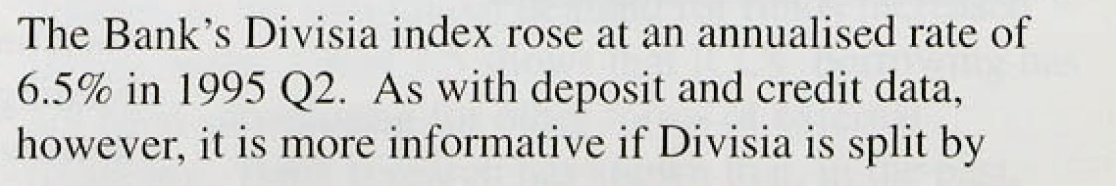





sector. Personal sector Divisia money increased sharply in the second quarter—by 5.99r on an annualised basis, the highest rate since 1990 Q2. And growth in 1995 QI has been revised up to 5.1% although this was distorted by Glaxo effects. Corporate sector Divisia money has also increased sharply relative to 1994; it grew at an annualised rate of 8. I % in 1995 Q2, much faster than in

the second half of last year.

In practice, Divisia money need not be an accurate guide to future inflation if increased holdings of some non-M4 assets, such as Treasury bills, are followed by higher transactions.



Twelve-month MO growth slowed from 6.3% in April to 5.7% in July, but it remained outside .its 0%M% monitoring range. On a three-month annualised basis, M0 growth was 3.2% in July, down from 8.0% in April. Part of the slowdown was the result of a drop in bankers’ balances in May. Although notes and coin constitute more than 99% of M0, the high volatility of bankers’ balances—which are determined by day-to-day developments in the money market—means they contribute disproportionately to the monthly variation of narrow money. Notes and coin provide a better guide to the underlying increase in narrow money. The growth of notes and coin in circulation continued to increase sharply on short-run measures. suggesting that the demand for narrow money has picked up. On a

three-month annualised basis, notes and coin increased at a rate of 7.1% in July, up from 6.19o in April.

In the past, narrow money—in particular notes and coin—has been a good statistical leading indicator of future inflation, probably because it can be a good measure of consumer spending. The demand for narrow money depends not only on desired transactions but also on .the opportunity cost of holding cash. This opportunity cost is captured reasonably accurately by the bank deposit rate, which is linked.to the UK base rate.

And much of the beiiaviour of narrow money .over the past lii months could be explained by the changes in shori-term interest rates. The cuts in interest rates ñetsveen Septqmber 1992 and February 1994 pushed the mate pf growth of notes and coin:up to a peak of 8.2&o on

.. ’ . . a three-month annualised,basis, in January, 1994. As the:

.effect, of'1ower interest rates began to wear off, the rate Of **increase** of notes **and** coin slowed to reach a trough ,of

,3.5&o ifi January **.1995:** The recent.fasler growth,of



narrow money is inore difficult to explain. Notes.arid coin hnve accelerated since the begirin:i.rig of .1595., a time when the opportunity cost of holding cash has been rising.

one-month. rise for almost a: year—but by a more modest



.,l ,| ‹› 0.39• in June rind 0.6% in July. This need not suggest

.I/ , i/ that consumers’ .nominal .demand is increasing, if the il\ 1/ relationship between cash in circulation.arid total

 y„ , ‹ii! consumer spending has changed recently—perhaps as a resull of the introduction of the National. Lottery. Since National Lottery sales are predominantly cash-financed, more cash will be held for,any given level of total



consumer spendiñg. (The average transaction is worth only £2.15, according to Camelot, suggesting that tickets

” 'i't,} ,!,',’,{; ;;{•' ;'',',',; }. ";'¿v„;;,"" * *°'****"-••' ^• would normally be bought with cash.) It is possible to

'' J/::' .‹. " ' ' ' ' " ’’""" "'“ ' d " "' *' '"" .make a rough estimate of the National Lottery’s impact

on notes and.coi.n growtli.. Ifoticket sales were financed from savings, and notes and coin :changed hands around once a montli, excluding National Lottery ticket sales

”' • would halve the.si.x-month annualise‹i growth. rate.!of notes and coin of 6.6%.. Since tickets wi!ll not be wholly financed from savings, and note:s and coin may turn over faster than once a month, this is an.overestimate of the impact of the Lottery; as such, it rep'resents am extreme case.

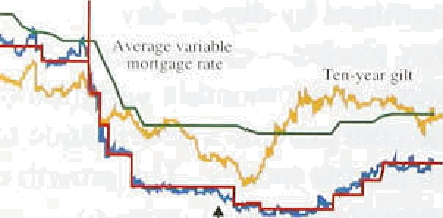

/‘

„ „ ,„, -

'

There are two othRT:reasons why the increase in narrow money growth is probably not!a strong signal of future in.Elation. First, any. spending on National Lottery tickets

.will put few pressures on resources arrd, therefore, have fewer implications for inflation .than other forms of consumer spending. Seeon‹J, it may ,also be'the case that a reduction in inflation expectations has Jowered .the .rate at which notes a!nd coin.change hands, increasing. measured money growth with no i.mplication for future prices—in!other words...there may have!been a long-run shift in tote *vetodi ot,*narrow money...'In such: ci.rcumstances, .the i.hcrease in.narrow money .growth is probably not a strorig signal of future iriflaiion,



# 2 2 n e est rate n e h e tes



-'..0.2



Since .the May, *Sepo’rt,* official UK interest.rates have

' rqmained unchanged at 6.75$•, the US authorlties have

.cut the federal funds rate .by 0.25 percentage points añd Japan has eased its money-market rates. France has cut its 5—10 day repo rat‹i by 50 basis: points, and Sweden. and Italy have ti!ghtened monetary policy (see

Table 2.BI). Chart 2.8.shows,some..of the interest rates



**Chart 2.t0**

**Sterllng Interest rates expectations‹•**

Mah0i cx ' iation4 as tit:' Pt r ciini







Sources. Bz«i «r emu a « a rirm

tab Be.wd en s.*ombrnsiion.or sterling inieeqrmie fuiures:contnicb.

**Chart 2.11**

**Implied forward interest rates**

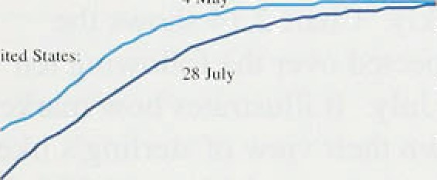



- 7.5

- 6.5

' - 60





**Chart” 2.12**

**Eitpected.real** Interest rates‹•i





paid by:different borrowers or used as a basis for

##### calculating their borrowing costs.

Three-month interest rates in the United Kingdom fell slightly from 6.94&o on 4 May to 6.81% on 28 July; but short-term interest rates in other major countries also fell. Chart 2.9 shows that, as a result, the interest rate differential between the United Kingdom and its trading partners has increased.

Futures markets have continued to revise down their expectations of UK interest rates over the next nine months. Rates on LI.FFE’s December contract fell from 7:90% on 4 May to 6.989c on 28 July. while those on the March 1996 contract fell from 8.11 9r on 4 May to 7.1 l to on 28 July (see Chart 2.10).

To look at developments over the longer term, the Bank has constructed yield curves for the other G7 countries using the Svensson technique, which is currently applied to the United Kingdom. The new yield curves are useful for international comparisons, since they take account of institutional differences between countries, such as the method used for calculating accrued interest. Chart 2.1 l compares the fitted yield curves in the United States and the United Kingdom on 4 May and 28 July: it shows that while US bond yields fell at every maturity, short yields were down in the United Kingdom. but longer yields rose.

These movements were also reflected in the unadjusted ten-year bond data. Although government long bond yields fell significantly in the United Kingdom between the beginning of 1995 and the beginning of May, they fell funher in the United States, Japan and Canada.

Since then, however, yields have risen in the United Kingdom and Germany. while they have remained low in the United States. As a result, UK ten-year bond yields were down only three basis points between 4 May and

28 July. The differential between German and UK

ten-year bond yields increased from 131 basis points on 4 May to 146 basis points on 28 July, while the differential between UK and US bonds widened from 139 to I7fi basis points.

The decline.in UK yields can be decomposed into the changes in expected real interest rates and in .expected inflation. Chart 2:12 shows that the average real interest

:iate expected over the fol1owi.rig ten years fell siynificatitly..after 4 May, but ;he decline was almost ompletely reversed'by 28. July.

 

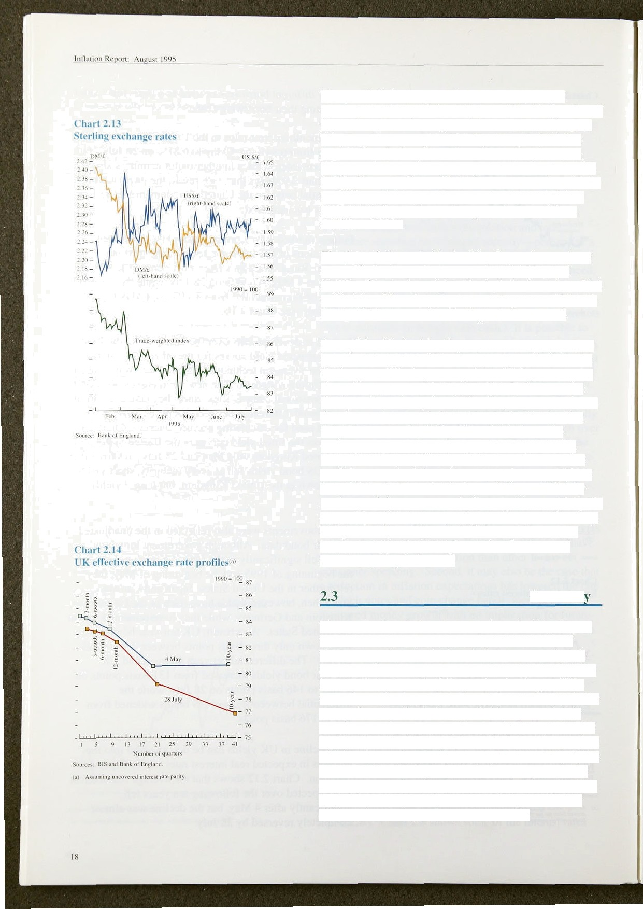Ten-year inflation expectations are relevant when analysing market participants’ view of the likely value of the exchange rate in ten years’ time. At the time of the May *Report,* there had been little pick-up in inflation expectations in the gilt market. Since then, however, long-term inflation expectations have increased sharply. Implied ten-year forward inflation rates rose from 4.36% on 4 May to 4.94% on 28 July. The average inflation rate expected over the next ten years increased from 4.10Yo to 4.58%.

The depreciation noted in the May *Report* has not been reversed. Sterling fell slightly between 4 May and

28 July. On a trade-weighted basis, it declined from 84.4 to 83.4 (see Chart 2.13). and was 6.37c lower on 28 July than on 24 January, when the depreciation started.

As explained in the May *Re f›urt,* there is no mechanical link between a fall in the exchange rate and inflation in the long run. The Impact on prices will depend on why the exchange rate has fallen. (Section 5 discusses the short-run impact on prices.) The May *Report* concluded that there was little reason to suppose that the decline would be reversed quickly. Chart 2.14 shows the exchange rate paths expected over the following ten years on 4 May and 28 July. It illustrates how market participants revised down their view of sterling’s likely future path. It shows that between 4 May and 28 July market participants came to believe that the pound would depreciate a little faster over the next ten years than they had previously anticipated. This is consistent with a belief among market participants that the stance of monetary policy had eased.

Summar

The acceleration in broad money since the May ftrpori cannot be attributed merely to Glaxo’s take-over of Wellcome, or to a rise in the relative return on deposit accounts. Credit has continued to rise strongly, with the increase in bank and building society lending to ICCs more than offsetting a slight weakening in lending to the personal sector. Banks have probably squeezed their margins over the past two years, in order to increase the supply of credit. The impact on inflation will depend on whether the acceleration in broad money persists. In the short run, this will depend on whether prospects in the corporate sector have improved and ICCs are borrowing to fund investment and take-over activity, or whether ICCs are borrowing to finance involuntary

###### stockbuilding. The demand for notes and coin in circulation has increased strongly. But much of the increase may be accounted for by special factors, and therefore may not presage future inflation.

1 9

Demand and supply

3.1 Total demand

The UK economy grew by an! estimated 0..6%. in the second quarter, compared with 0.7% in .the ffrst. In. the year to the second quarter, **GDP** rose by 2.9%. As Chart 3.1 shows, quarterly growth was lower in the first half of this year than in most .of 1994; the profile was similar for non-oil GDP, which rose by 0.7% in the second quarter, compared with 0.6% in the first. Since the May Report, revisions liave raised estimated growth in the third quarter of last year by 0.1 percentage point and lowered it by the same amount in both.the.fourth and first quarters.

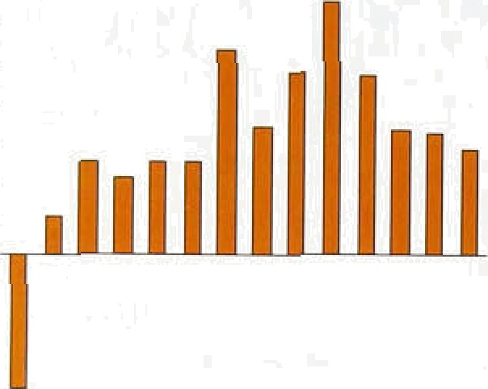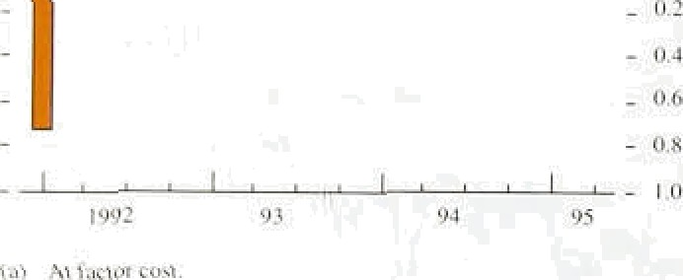

Nominal **GDP** rose by 0.69r in the **fiISt** Juaner and was 4.5% higher than .in .the same pgriod last year. Over the past 40 years, real **GDP** has grown, .on average, by 2%—2!/i% a year. With the inflation target of 2'/i% or

 less, this suggests that nom.i.nal **GDP** should rise by around 5% a year over the long run; .in the first quarter, it was growing at below that rate.

Cunsuniytitsn I .9 2 ?  -U.l

### 0.1 3.2 Domestic demand



Ch:in 3.2 lJoniestic denda nd



1.6 -0.7



Domestic demand fell sharply in the first quarter, and GDP growth was entirely accounted for by tire ,strength of net external demand. (Table 3.A shows recent contributions to **GDP** growth. A lfull breakdown of.GDP is .not yet available for Q2.) The erratic pattern of domestic demand. in the fourth. and first quarters (shown in Chart 3.2),is eKplained .mainly by high spending by.

UK residents abroad in the fourth .quarter (particularly .in

.December) and also by! tlte strength of stockbuilding in

Q4.

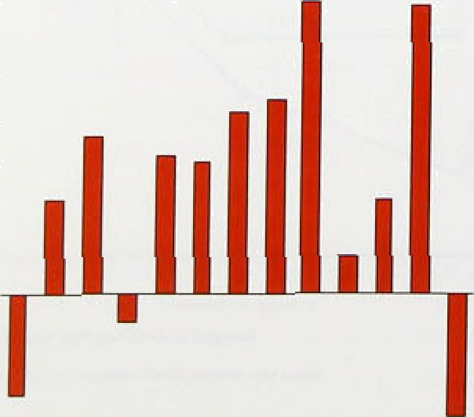

Exe1ud"ing.stocksow

h’ic"h*incorporate d a 1arge

alignment adjustment in Q omestic demand was roughly flat i!n the first quarter. .Because of„the erratic profi!Ie of stockbui.1di.ng and touhst spending:at the turn of the year,. it. is lbetter to l'ook at the.fourth.an d.first quarters together: Table 3.B shows ,that ihé six-,month growth rate of doinestic deiiia!nd' slowed.in the second. half of.last.ye‘ar, but since then'has’been broadly flat.

*Personal sector. demand*

##### 'Consumption fell.ñy 0.1% .in US Q1.,. its: first quarterly.

:fa11:since the recover i!n GDP begari three yeârs earlier.





**Table 3.B**

**GDP and domestic demand growih**



..GD.P Non-oil GD.P Domestic Domesiie

demand demand.



st Id



Q3 2:.4 2.2 1.1 OPB

@ 2;.0 2:0 T.2 :0..8

Q2 l.j 1.3



(e’ LmWR'ksDnifisxpw;i‹wssñmonAs

**Table 3.C**

**Contributions to consumption grnwth** i•i



Durable good5' 0:9 l.l 0. I —

0.9. —. —



I.0’ 0.7 -0.1

TQMkCOMStlmpROD’ 2.6 3JB 0.8 •0•I



Spending rose strongly in the fourth quarter (driven by unusually high tourist expenditure), so some fall in growth was probably to be expected in the first part of this year. But growth rates averaged over a longer perio‹i have also fallen: taking the four quarters to Q1,

consumer spending rose by an average of 0.59r a quarter,

compared with 0.89• in the four quarters to 1994 Q1.

Consumption accounts for about two thirds of GDP; if growth in consumption slowed signlficantly, it would therefore have important consequences for the economic outlook. Table 3.C shows that consumption growth was broadly based in 1993 and 1994. But growth in durable goods spending, which tends to fluctuate more than other types of consumption, fell throughout 1994 and in 1995 Q1. Spending on non-durable goods was also weak in the .fourth and first quarters. The fall in housing market activity probably affected spending on

housing-related goods. And increases in taxation from

.April 1994, and further rises from April of this year, may

###### also have slowed consumptlon growth.

Subdued consumption of goods in the first quarter was consistent with the fall in retail sales volumes, but it contrasted with a rise in real personal disposable income of nearly 29. Nominal income from employment rose by 1.5&r in Q1 while the rest of pre-tax personal income rose by 3.2&o—including a sharp, though by no means unprecedented, rise in .investment income. Because consumption fell and income rose, the saving ratio. which fell last year, increased by 1.8 percentage points in Q1. to 10.6%.



**Chart.3d**

**Growth in components of retail sales**











- .6





Spending on services fell in the first quarter. This reflected the fall in UK residents’ spending abroad from its high at the end of 1994; spending on the rest of services increased. The strength of the latter accords with the strong growth in service-sector output, which probably reflected both personal and corporate sector

##### .activity.

Retail sales rose by 0.49o in the .second quarter of 1995. suggesting that consumption may have recovered (retail sales account for around 40% of consumption). And the strong growth of consumer credit in Q2 (see Section 2) also,suggests a stronger outlook. But the main Components of retail sales reveal an interesting

!div gence,.as Chart.3.3. shows. .In the second quarter, the volume! of house.hold-good:and other.non-food sales (Plainly by, small traders, such. as, newsagents and. 'Cheinists) wen lower,than a year earlier. The weakness



2.1



of household-good sales is consistent with relatively subdued consumer confidence and lower housing turnover, and supports the view that lconsumers remain highly price-sensitive, awaiting the summer sales before ñuying bigger-ticket household goods.

Hiiusiiig **market urti** s its!



— I G0

The new car market also illustrates the reluctance of consumers to buy expensive items. New private passenger car registrations were around 7&• .lower in the first six months of this year.than in the same period of 1994, while anecdotal evidence suggests that sales of nearly-new ears were strong. This contrast, however, is typical of periods of weak domestic deman‹d (A box in the May *Reyort* reviewed recent developments in the UK vehicle industry.) Lower falls in unemployment, and flat employment in the first half.of this year, .help to explain consumers’ price sensitivity and.spending caution.

Chart 3.5 House prim

*Housing mv rket*

”" Taken together, housing market activity, lending and price data suggest that the demand for housing weakened in the first half of this year. Housing

turnoveI, 8s measured .by particulars delivered, fell in the first and second quarters. Prlvate-sectpr housing starts, shown in Chart 3.4,.fell .by around 3% between the three months ending in May and the previous three. Chart 3.5 shows that house prices fell in each month of the second quaner, according to the Halifax Building.Society"s index. Bank and building society new lending for house purchase rose in May, but was still lower than in December.





- f10

.Two .cyclical factors help to explain the downturn in the housing market in the first.half of the year. .First, the increase.in official interest rates of 1 '/ percentage poihts since September 195 nd conee'rn about possible further increases—probably affected the housing.market adversely. Between .September 1954 and.July 1955, variable mortgage .ratestrose by about half as much:as base rates, as lenders attempted to cqshion the impact on mortgage lending. The rise iq long-term interest rates

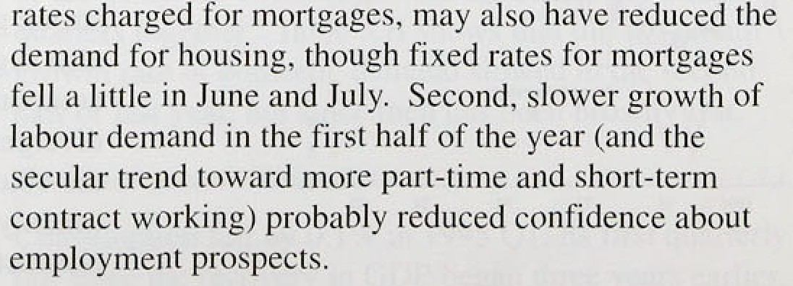

u

22



Chgit.3A

**Biisiness** investment•› over **the** cycles ›

Tmu#af€DP=1OO

###### The.housing market is probably still adjusting to the shocks it has suffered, such as changes to the tax

„ treatment of interest payments, reductions in income homeowners (to take effect later this year),



- ssi .ei





**Chart 3,7**

**ICCs’ gearing and financial deficit**

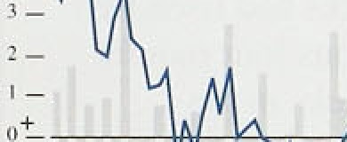

’- 120

* I l5
* I l0

- l0D

###### and a re-evaluation of the risks of investing in housing. An environment of lower actual and expected inflation means that the demand for housing as an inflation hedge will also be reduced. An article on pages 260—69 of the August *Quanerly Bulletin* develops some of these themes in more detail.

Gross investment fell by 0.2% in the first quarter; as Chart 3.6 shows, business investment has been subdued during the recovery. By the first quarter, it had fallen, compared with a rise at the same point in the previous two recoveries. This profile partly reflects low investment by utilities and mining companies (which had invested strongly before the trough of the recession).

But although investment by the rest of the business sector grew, by the first quarter it had risen by much less than in the previous recovery—and by less than investment in the United States at the .same point in the recovery there. Manufacturing investment, which rose last year, fell in the first quarter.

’’’’ ’'’’ l980.’.

s’3.’

’.- 0

00 9S



###### The relative weakness of business investment contrasts with the significant strengthening of corporate sector balance sheets over the past three years (see Chart 3.7), as companies used rising profits to pay off existing debt. Firms’ income and capital gearing probably stopped falling last year: In the fourth quarter of 1994, ICCs were net bank borrowers for the first time in about three years .(see Section 2); they continued to borrow in the first half of.this year. The buoyancy of UK equity prices, shown in Chart 3.8, probably reflects the fall in real interest rates earlier this year (which pushed up the price of index-linked gilts) and in the real exchange rate, but also.suggests some market confidence in the outlook for corporate profits (though there might also have been a:change i.n the risk premi.um in holding equities relative to:borids).

.This:iñcrease in .corporate borrowin" which



iaccompanied.high industrial..capa ity utilisation, may

###### foteshadow/ari increase in investment.

The CBI Survey

i:nstance; showe0.that.over the previous year ihe need to expand.capacity°liad ‘bec,ome: a more important/ieason.**for}irost›octivé** inFéstment. It also



: **fipod8lf.a,bdldOCC.Of.** *,7âo* of Imms: expecting .to increase

"

**Stock cycles**

A key I:ictoi affecting the future of the UK recovery will be whether companies will want to rrniintain the stocks built up in recent quarters. If firms deliberately increased stocks to meet rising demand and their confidence is justified, output will grow quickly, augmented by stockbuilding ; if not. and stocks have built up as a result of weaker than expected demand, companie.s may reduce output over the rest of thin year—indeed,

the recent slowdown in the United States has been attributed to the unwinding of just such a ’stock cycle’ .

A1thc›ugh the evidence on stocks is complicated by the ‘alignment adjustment’ to the national accounts which is included in the CSO’s estimate of stockbuilding, it is clear that stocks have increased sharply. According to the national accounts, stocks inci’eased by ti0.8 billion (at 1990 prices) in the first quarter of 1995 following a rise of £1.4 billion in 1994 Q4. Figures excluding the alip•nment adjustment show that stocks grew’ by around '/•°Zr of GDP a quarter throughout 1994 and in 1995 Q I .

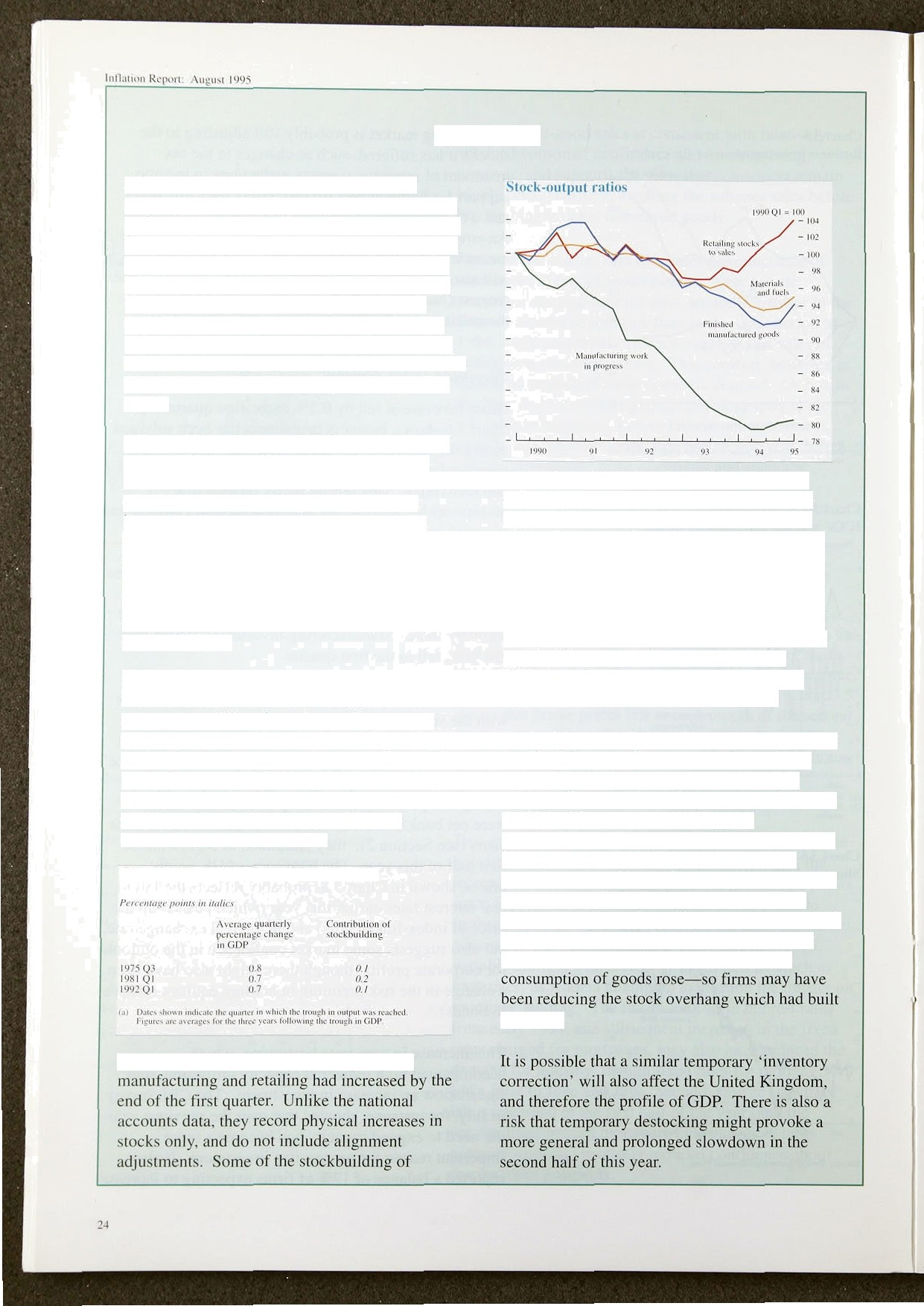

Stocks are probably less important to firms now than in the 1970s and 1980s—the ratio of stocks to output has fallen since about 1980, perhaps because of improvements to inventory control, such as just-in-time production and delivery. But by the first quarter of 1995, stockbuilding had, on average. made about the same contribution to **GDP** growth as it did in the previous two recoveries, as the table shows.

The chart shows how stock-output ratios in

materials and fuels may have been voluntary, reflecting precaution against supply and price pressures at the early stages of the production chain. But some of the rise in manufacturers’ finished goods and retail stocks was probably involuntary, as domestic demand turned out weaker than expected. The July **CBI** Survey showed that manufacturers' stocks had risen by more than expected in the previous four months and that they expected to cut stocks in the following four—also suggesting involuntary stockbuilding in the first half of the year.

In all of the other Group of Seven (G7) countries, stockbuilding contributed to GDP growth last year. This may have been largely voluntary because of expectations of rising demand. But in the United States, some of this year’s stockbuilding was probably involuntary, as in the United Kingdom. US industrial production growth weakened *in* the first half of this year, but stocks rose in Q1 probably because domestic demand growth weakened by more than expected. **In** the second **quarter, US firms** built **up fewer** stocks, while industrial producbon fell and

up in Q1.



**Chart 3.9**

**Factors limiting capital .expenditure**

- 70

##### .investment i:n plant and machinery over the coming twelve montbs, compared with 6 r a year earlier.

Nevertheless, it showed that uncertainty ;ibout future

demand was .still an important factor limiting capital spen:ding (see Chart 3.9). Foreign demand remained strong in the first quarter. but firms may be more reluctant to increase investment if domestic demand is

###### much weaker (partiCllla r1y because exports are mold

_ - 30

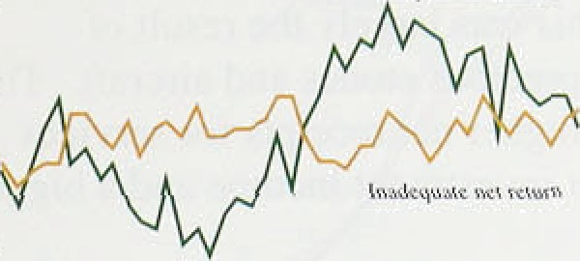

volatile than domestic demand); the outlook lot overseas demand (panicularly from the United States) became less certain in Q2.

Souisc: PCB l iiiéuuna} Trcndi SuNcy.

*Siockhuilcliiig*

' Firms continued to build up stocks in the first quarter.

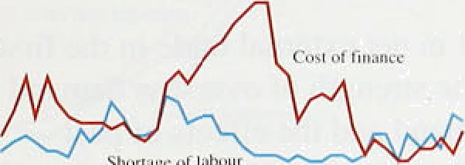

But because estimated stockbuilding was even higher in the fourth quarter of last year. the contribution of stocks to growth was negative in 1995 Q1. Stockbuilding is the



most volatile component of domestic demand; in the fourth quaner, it also included a large ‘alignment adjustment’.( Excluding the alignment adjustment. stockbuilding fell by much less in the first quarter. The box on page 24 looks at stock cycles in more detail, and assesses the implications of the high stockbuilding in 1994 and the first quarter of 1995. It concludes that there may be some destocking over the rest of the year, affecting the profile of GDP. and that this could lead to a more general slowdown in the second half of this year.

*Public’ sector demand*

In the first quarter, government spending fell by 0.2' c. Public-sector investment (which, together with general government consumption, makes up government spending) also fell; it had nsen strongly in the second half of last year. In 1994, government spending rose by 2.6&», contributing about a fifth of the rise in GDP— more than the contribution of net external demand (see Table 3.A). In 1993/94 and 1994/95, general government spending (as a percentage of GDP, excluding privatisation receipts) was less than original Budget projections.

**3.3 Net external trade**

Nét external trade accounted for all of the rise in GDP in the first quarter. The voluiie of goods and services exports rose:by .0.8'7•, while import volumes fell very shyly.: The.latter'largely reflected a fill in imports of **’services as fewer UR** tesidefits.ttavel1N abroad.

’ . (fj Alt :8t1fffh.t Ad)fl6tfile.Rt.S.. RSu.ft that..e*} 42dittim.and.incoIDe.measures of.



lnfltiliciu Report: **August** I % i





Year Year g4 Q1 g2

-13.4 - IO.5 -3.0 -2.0



-/ti7 J.f7 -/./ -0.6 -/.0



C‘urrcnt a«ciunt h:ii:ince / /.rJ - /.7

‹T.‹ ‹r /7cr 'rr r ',gr //CHD/' *l. 8* •0../





**Real** eflectii’e **exchange** ratesi•›









- - 90



ts i nominal.éffwiivr exchange mm.adjvstc'J Air changes \n relaiiyr

.Despite the strength of net external trade, the current account deficit—at 0.2&r of GDP in the first quarter— was broadly unchanged from Q4. As Table 3.D shows, the visible trade deficit fell by around fi1 billion in the first quarter, although this was largely the result of changes in trade.in oil, precious stones and aircraft. The invisibles surplus felt; higher net receipts for services were offset by lower net investment income and a bigger deficit on transfers.

The sharp improvement in net external trade .in the first quarter reflected both the strength of overseas demand relative to domestic demand and the effects of past improvements in price competitiveness .brought .about by exchange rate depreciation. In the first quarter, UK domestic demand fell, contrasting with a rise in the rest of the G7 countries. But there lias been increased concern since the.May *Rep.ort* that growth in the rest of the world will slow sharply, affecting UK net external demand adversely, as a result of a previously uneKpected slowdown in the United States. Consistent with this view, non-oil export volumes (to non-EU countries) fell in the second quarter.

US GDP rose ñy 0.7% in the first quarter (compared with 1.2% in Q4), and by 0.l9« in the second. In Japan, GDP rose by 0.1% in the first quarter. after a large fall in the fourth. However, there is less evidence that European grpwth slowed in the first part of the year: in France, Italy,and Spain, GDP in Q1 rose try more than most commentators had expected. And it is probable that US demand Bill rise in the second half of the year, as the effect of lower long-term interest rates and high business investment feed through. Some forecasters

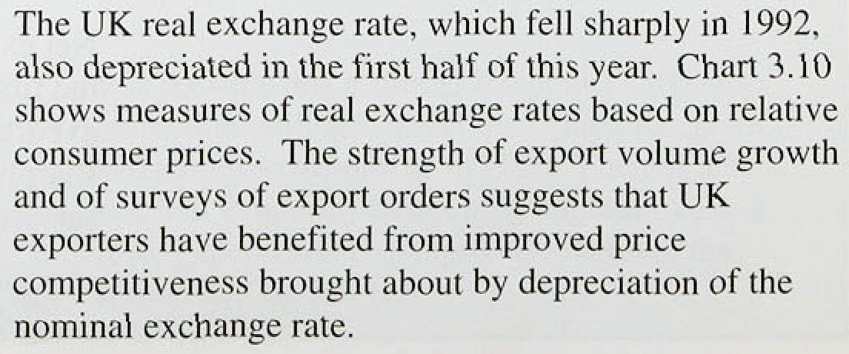.have revised down .their projections.for world growth, but.the OECo’s June *Economic Outlook* projecte‹i that EU GDP growth would rise to 3% this year, similar to its December projections. OveraH, although the probability that world growth will,be significantly weaker for the rest of this year has increased— reducing the strength of UK.net external demand anfi,of more widespread,.world, inflation.pressures it is sñll

Ghart 3.l1‹ ›

GDP by tor





* Swviccs industries



95

(at ngfic*liun• end consiiuciion em ver:shown in the chen.

Chart 3.t2

Output and expenditure on goods



- -+ 2

Expcndiiurc tb}'















###### The strength of exports over the past two or three years has led to suggestions that the United Kingdom’s trade poJormance may have improved permanently—perhaps as a result of earlier inward investment or higher productivity. But the rise in export volumes last year was not unprecedented and, by the first quarter, the contribution of net exports to this recovery was less than

in the 1970s .recovery (though higher than in the 1980s).

And according to the OECD, the United Kingdom’s share of world export values, at 5% in 1994, was about the same as five years earlier. It is difficult to explain the

rise in export volumes in 1994 solely by the strength of world demand and improved UK price competitiveness. But while.higher investment—or other non-price improvements—may have played a role, it is too early to conclude that UK trade performance has improved fundamentally. )

3 4 Out u

Output rose by 0.6% in the second quarter. Non-oil output rose 0.7%, compared with average quarterly growth of l% in 1994. Manufacturing output was broadly flat in the first five months of the year. compared with a rise of around I 'his in service-sector output in the first half of the year.

###### In the first three quarters of 1994, the output of production industries rose more strongly than service-sector output (see Chart 3.11); its recent

weakness may be a response to weaker than expected

.domestic demand. Supporting this view, Chart 3.12 shows how the growth in spending on goods slowed in 1994 and the first quarter of 1995, while growth in output of goods fell by less.

The growth in service-sector output in the first quarter was broadly based. Chart 3.13 shows that .output in the transport and communication industries grew particularly strongly from mid-1993. These services are complementary to tradable goods; business spending on transport and communication may have increased in response to the strength of.industrial production and export demand. So the.divergence between strong exports and weak domestic demand can affect the services sector as well as manufacturing. Buoyant spending!on. c1orp:orate services probably also reflected expectations of relatively strong clorporate demand, followi .the post-recession improvement in business profitafii!li . High.growth.in service-sector.output also





1ttflatit›n Repurt: August 109fi _ _



ñ l:i ii ul’iici uriiig i›iil put grnss th and Cfl I



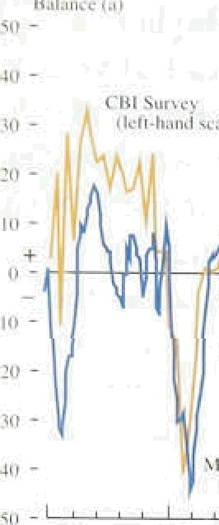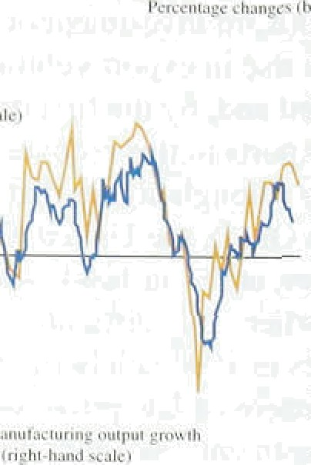





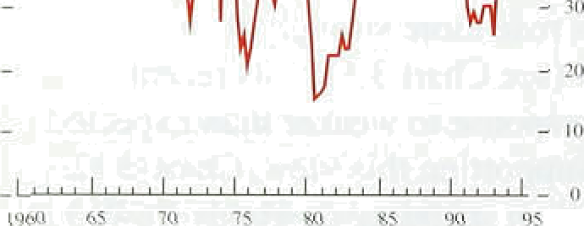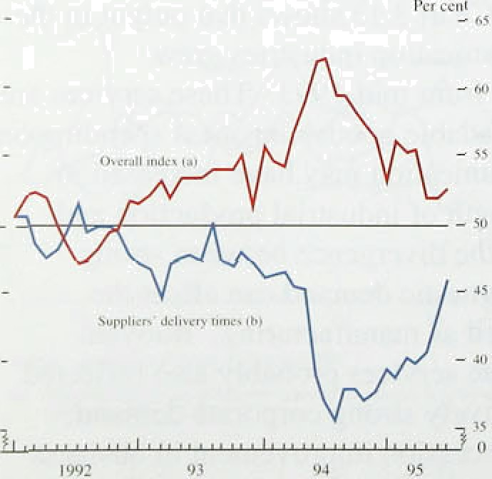

5ytoc: Ti1c'Neriwed' tneiNic;Of. Pumhnsiag end *Gnpply.'

###### accorded with the British Chambers of Commerce

(BCC) Survey, which showed that confidence and orders. remained strong in the sector in Q1, although they fell in Q2, following the earlier slowdown in manufacturing.

Survey evidence and reports from the Bank’s agents continued to .be stronger than recorded industrial output, though most surveys reported slower growth in Q2.

Chart 3.14 shows that CBI output expectations remained high in the first half of this year—though the net balance was lower than in the late 1980s-while

manufacturing output was flat. But the chart also.shows that, although the two series have moved broadly together, the recent gap between CBI and CSO data is not unprecedented. It may be explained partly by the nature of the recovery, as around .two thirds of **CBI** respondents are exporters—a much higher proportion than in the CSO’s survey.

Manufacturing capacity utilisation fell over the previous four months according to the CBI’s July Survey, añd was below its previous peaks—see Chart 3.15. According to the CBI, around a half of firms take account of labour as well as physical capital when afiswering its Survey’s questions about capacity. So the reported rise in

capacity utilisation could reflect the hiring of contract and part-time workers at the margin, rather than a tightening of physical capacity constraints.

###### Nevertheless, suppliers’ delivery times lengthened in the first half of this year,. according to the Chartered Institute of Purchasing and Supply (CIPS) Survey„suggesting that demand continued to outstri:p supply (see Chart 3. l ñ).

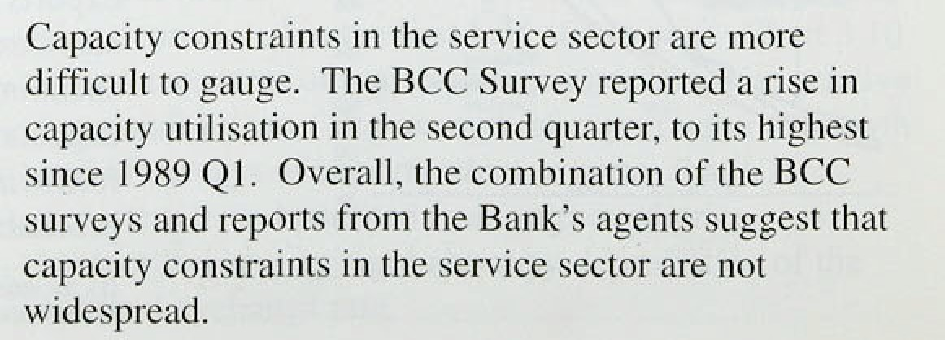Pressures on capacity differ among industriesl: .in the chemical sector, utilisation rose sharply in 1994.and has remained above the economy-wide average„ whereas in lthe .motor vehicle sector it was below average.in.the first half.of 1995.. According to the **CBI** Survey, however, the current.sectoral..divergences i!n capacity utilisation.are not unusual. The **UK chemical** industry provides a useful illustration of sectoral ‹differences in.utilisation, exports and output, and also shows.how cost añd pnce pressures are building in the supply chat'n see the:box on page 29. "





,II







The.:chemical indiistry account .fpr around. 2'/:% of

.QDP 1ast,ye ,.about:as..Enrich,as:the Vehicle industry.

.By the fiirst,quarter,:chemical output ha‹i risen b.y l.2°ñ



7%.for:manufntucing..in;lustry 'as a whole (see Chart A). Most ofithe output.of the.chemical industry is supplied to .other inanufacturing in’dustries,. many of which are

iexperieneingistrong expori growth. The buoyancy or cbemical output ihus owes much. to .the strength of exports by:other sectors: between the trough in GDP And the: first'quarter of 19.95; chemical export volumcs

’illustrâtioii.of.cost and price developments.at the intermediate supply stage. The price of imported chemical inputs rose by more than 209a in the year to June, accounting for aboul a quarter of the rise in manufacturers’ iriput prices. And although overall input price iñfiation. fell in Q2: chemical input price inflation did not. This reflected high capacity utilisation and also exchange rate depreciation: around 707c of chemical imports are from the European Union; many of which are priced in Deutsche Marks: the Deutsche Mark appreciated by around 5%i against sterling between Q l and Q2. In the iwelve months to:J une, chemical output price inflation. was 7.8°ñ and, as Chart. B shows, it has

C’hiiri II

Pr‹itluvcr ‹ml{oil p rirv in flit lii›ii



Chad.risen fly less than total non-oil expori volumes. -



CIlc›n1c al iiJd u Hr}'

„, been higher than aggregate manufacturing output price inflation since the fourth quarter. This suggests that

i«, earlier input price rises are now bei9g passed through the intermediate stage of supply and that. in the short

*• term at least, manufacturers closer to .the consumer have absorbed some of these price rises.

Strong output growth led to a sharp rise in capacity utilisation in11953 andiearly 1994 an‹i, according to the

.CBI,Survey in July, the industry was. at a higher level of utilisation than for manufactiiring as a whole. However, this, has,fieen so for most of the past twenty .years, perhaps because chemical production is:generally:more capital! intensive than some other manufactunng sectors: and therefore it is more efficient.for chenucal plants i!to

.run at higher levels of utilisation. Cnpyity constraints were confirmed by the CIPs Sijryey,which reported horiages!ofi„a range.of clier;ucals:and chemical’ derivatiyes in.the first half of this. year. 'Overall, although capacity constraints have increased, they are (ower than in the late..l9B0s-=-which4s also true for!the nianufa‹ituring sector as a whole.

Atoiipd thee quartérs of chemical output is consumed by nther industries, bo ths **sector proiides a** usefiil

Rising capacity constraints. arid higher prices within the secior. did not affect chemical industry investment much last.year; it fell: compared with a.rise in investment by the resLof the rñailufactusing sector. In

part; ho:wever,.weak.investment byiitfie chemical industry

.reflected:the stitri%t1i of in.vestmeñt n few years.earlier, particularly.in esirnent ink:énviroñinéiital projects, fol.lowing legislation. is year,;cheinica1 iii.véstrrient intentions have incieâsâfi by iñoté than thé manufmturing.sector'as’a whole. In the July **CBI**



as the rciaso hirer jitoportion thart.in th’ e..rest .of manufactunng„thougJ that:has not .been unusual. oyer the past five. years. .Overall, cheñiical investment with probably increase this year, relieving some. of Je pressiirei pn capacity. ’



"



Capacity utilisation tose further in lthe economy .as a whole in the first half of the year. And, as output grows relative to the capital stock, firms are likely, in the short run at least, to react to higher nominal demand by raising prices. It is difficult to measure the amount of spare capacity .across the economy which eoiild be used without generating inflationary pressures, since it depends partly on the pattern of demand and.supply— which differs between cycles—and in any case measurement of output gaps is highly sensitive to the assumptions .used to define potential output. When demand for tradable goods and services is much stronger than for non-tradables (as at present), the output gap.also depends on how easily resources can be shifted to the production of tradables. So estimates of the output gap can vary widely and are subject to large margins .of error.(') Nevertheless, as discussed in Section 4, whatever the precise level of the natural rate of unemployment, it has probably fallen and, on most estlmates, actual unemployment is above it. Consistent with this, the IMF and OECD estimate that the United Kingdom’s aggregate output gap will average around 29 in 1995.

## 3 5 Su a

Output growth slowed in the second half of 1994; since then, it has been broadly stable, growing at—or just above the growth rate of productive potential.

Domestic .demand fell in the first quarter of this year, while net exports were strong. Manufacturing output was broadly flat in the first part of this year; the buoyancy of survey data reflected the strength of the tradables sector. Manufacturing output.may also be hitting capacity constraints, although this is restricted to certain sectors, and it is likely that there. is more spare capacity..than simple melasures of utilisation.suggest.

Service-sector‘output, particularly of transport and communication services, grew..strongly in!tlie ye.ar to Ql., linked to 1earlier.strong growth of"export demand and perhaps expectations: of riding demand .in tlie futuye. The strength ofi tfie eqaity.market i*,tfie first,.seven, months of this year also suggested:some market confi‹ience‘in future coyp0râte .pr6fitability, .Qi1 **balance,** al:t1iough demand and output growth.we%ened.in the second lialf

of 1994, singe then growth has beefi’roughly constant, and it is ufi!likely tliat i!t will slow much further in the seconJi'hnlf’of the yeah, "The main danger is:a downturn

.due‘to destoching.









Chart 4.1

Earnings growlh and RPI inflation

*

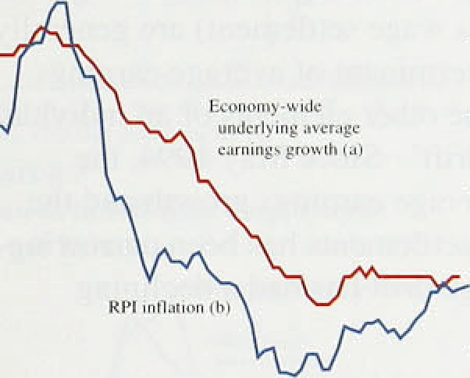

—

earnings:growth lal

-

1990 91 Q2 93 G'› 95

— I0

- 2

The growth rate of nominal underlying average earnings was 33/4% in May, unchanged from April but a quarter of a percentage point above the February and March rates. As Chart 4.1 shows, underlying earnings growth has been remarkably stable recently and has not moved outside the 3'/*9«—4% range since January 1994.

Furthermore, in May the growth rate was only three quarters of a percentage point above the trough of 39r recorded in November 1993; over the same 18-month period, the tax and price index measure of inflation rose from 1.4% to 3.8% and the headline rate increased

from 1.4% to 3.4%, implying a reduction in real earnings growth. Chart 4.2 shows that the growth rate of real average earnings declined from the beginning of 1992, and in the first quarter of this year was close to zero.

inéisinal: divjui0* aad 'ihe* in'fiue'ncJc of pubtiC htl idzys in ivlaiion



Chart 4J.

.ReaI average earnings growth

Actual nominal earnings growth has been more uneven. The headline measure of annual average earnings growth increased to 4.3% in March from 3.29c in February, largely because of changes in the timing of annual wage settlements between last year and this. In April and May, there were fewer such distortions and the growth rate fell back to 3.8% and 2.9% respectively. In producing the underlying series, the Employment Department adjusts the headline data to allow for temporary influences such as the effects of back-dated

' pay, industrial disputes and changes in the timing of

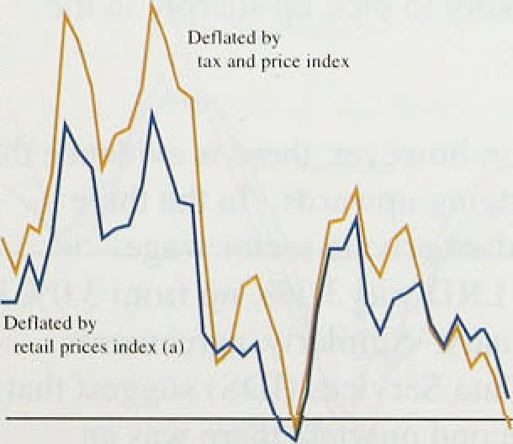

- 3

settlements.

The strongest wage pressures in recent months have been in manufacturing, where underlying average earnings increased at a twelve-month rate of 4’f•% in May, unchanged from the previous month. In the services seetor„ average earnings growth has been much lower, at 3!& tsee Chart4.3), largely because. of the weakness of the twn.largest Sub-sectors: retail trade and mpairs, and edueation„health and social work—the.latter of which is do:ni:riated by the public sector. Each of these categories accounts for afiout 19% of the services sector.

Comparing ike file months to May with the same





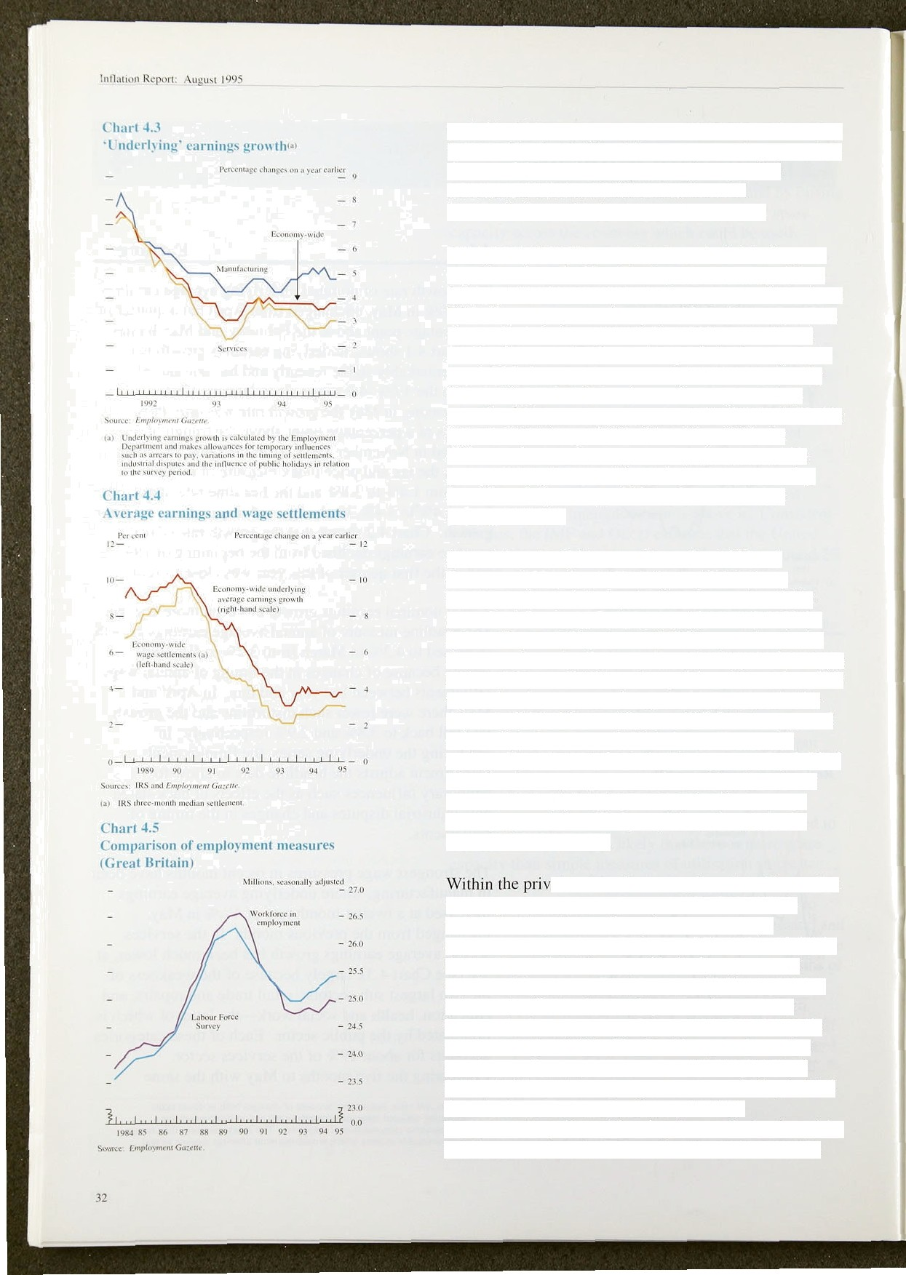period in 1994. average earnings in these two sub-sectors increased by just l.She, while average earnings growth in the rest of the services sector rose by 4.0%, with increases of 4.4% and 9.3% in the financial intermediation and 'other’ services categories.

Average earnings figures relate to an individual’s gross pay. Data from the New Earnings Survey suggest that, for the economy as a whole, basic wages constitute about 75% of gross pay, overtime pay 14% and bonus pay 79o; the remainder is accounted for by shift payments and grading increments. Hence changes in basic wages (the standard definition of a wage settlement) are generally the most important determinant of average earnings growth. Changes in the other elements of an individual’s pay are called ‘wage drift’. Since May 1994, the difference between average earnings growth and the medfan level of wage settlements has been narrowing (see Chart 4.4), so wage drift has had a declining influence on pay.

After rising slowly between December 1993 and December 1994, the median wage settlement was broadly unchanged during the first six months of this year. Both Industrial Relations Services (IRS) and the Labour Research Department (LRD) report that, in the three months to April, the median wage agreement across

all industries was 3.0%, unchanged from November. IRS report that there was no change in this position for the three months to May and June, and LRD data suggested only a slight increase to 3.1% in May. This recent stability is particularly important because roughly half of all collective wage agreements have either January or April implementation dates, suggesting that average earnings growth is unlikely to pick up sharply in the second half of this year.

ate sector, however, there is evidence that wage agreements are edging upwards. In the three months to May, the median private sector wage agreement recorded by LRD was 3.3&n, up from 3.0% in the three months to January. Similarly, agreements monitored by Income Data Services (IDS) suggest that between the first and second quarters there was an increase in the proportion of private sector pay awards worth more than 3.0&•. The Bank’s agents have also noted more firms agreeing wage claims in excess of 3.0&». Public sector wage agreements are falling behind those in the private sector, as a result of the Government’s policy of freezing the nominal **value of** the public sector pay bill. IDS note that most increases in

**’Chart 4.6**

.Growth **in part-time employment**

**(Greal Britain)„**

the public sector effective in the second quarter have been less than 3%.

Fwrentng 'changes on a year cert i

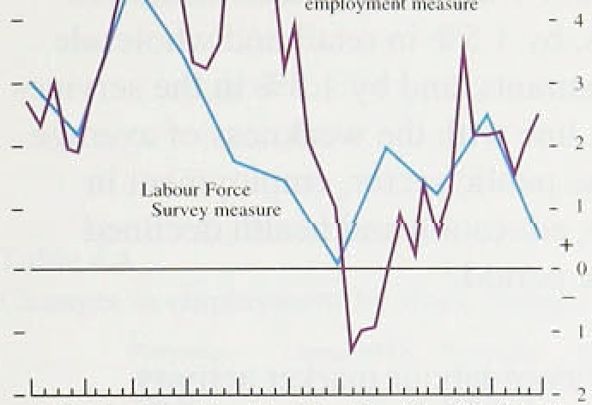

t'jB5.' 86 ’8’7 .8g g9,’ 90. +I 9.2 93’ !›4 Vfi

Soumea. C8O had L0bouz Foitc4 Sui+key.

**Chart 4.7**

**Crowth in full-time** employment

**(Great** Britaizt)



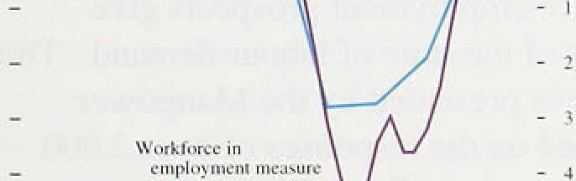

**Chart 4&**

**Growth in labour demand IGreat Britain)**







- - I





'-W.nhAswiâ:.'





## 2 o e a d

Data released since the May *Report* suggest that growth in the demand for labour slowed in the first half of this year. Following two quarters of strong increases, the estimated workforce in employment (based on a survey of employers) fell by 12,000 in 1995 Ql. Similarly, although the Labour Force Survey (LFS) measure of

employment (based on a survey of households) increased by 25,000 between winter 1994/95 and spring 1995,(1 the r iSe wa S significantly smaller than was recorded in any of the previous seven quarters (see Chart 4.5). Will this slowdown in demand be temporary or sustained?

There are.a number of reasons for expecting it to be temporary. Foremost among these is the fact that the figure for total hours worked—the most comprehensive measure of labour demand—has increased faster than employment growth. The explanation for this can be found in the composition of employment growth.

Although there continue to be some discrepancies between the two data .sources, the LFS data strongly suggest that over the past year there has been a switch out of part-time employment into full-time employment, and away from self-employment into positions as employees (see Charts 4.6 and 4.7). Over the year to spring 1995, this shift in the composition of employment was consistent with the 0.79c increase in average hours worked and the larger 1.9% rise in total hours worked (see Chart 4.8).

Looking at employment. growth by industry, the latest LFS has partly resolved some.of the differences between the two sources of data. Despite the weakness of industrial production in Q4 and Q1, both now suggest that manufacturing employment has increased. In the year to this spring, the employer-based survey showed a rise.in manufacturing employment of 0.9&o and the LFS recorded 0.6% growth. As mentioned in the May *Rep,ort:,* this modest increase represents a very stron:g performance relative to tire sector’s trend decline over Ue past 20 years, helping to explain the strength of





**for'example,** the latest **figure for** the.





average earnings growth in manufacturing. The service sector, however, has continued to show the strongest employment growth (consistent with output—see Section 3). LFS data indicate that in the year to spring 1995 employment increase‹i by 4.0to in transport and communications, by 3.4% in financial intermediation and business services, by l.59c in retail and wholesale trade, hotels and restaurants, .and by I.f›% in .the services sector as a whole. In.hine with the weakness of average earnings growth in the public sector, employment in public administration, education and health declined slightly over the same period.



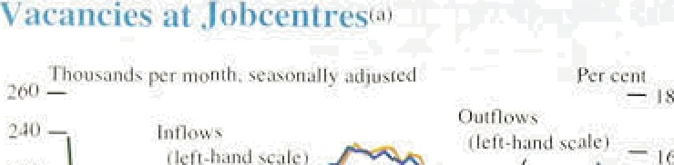

— 12







Most inciirect indicators of labour market activity support the evidence of a slowdown in the first quarter of this year. The monthly number of placements made by Jobcentres .fell by 7,700 between December and March the largest quarterly decline in four years.

Similarly, monthly notifications of vacancies, to Jobcentres fell by 11,300 in QI (see.Chart 4.9). Since March, both notifications of vacancies and placements have increased slightly; but not by enough to reverse the falls seen in the first quarter,

The various surveys of employment prospects give different impressions of the state of labour demand. The most buoyant picture is presented by the Manpower Survey, which is based on .the responses of over 2,000 companies nationwide across all employment sectors.

Both the March and June Surveys found that ,the number of employers planning to take on staff over the following three months exceeded the number who expected to: reduce employment. Al!thoug.h not.consistent with the decline seen in .the workforce-in-employment data in 1995 .Q1, there.was evidence in both these surveys of a slowdown in the:net rate ,of increase compared with that in 1994. The CBI’s July .Industrial Trends.Survey reported that.the net balance of:firms.that:had increased employment in the previous.four.months. rose .slightly relative to the position in Aprit, continuing tire gradual improvement that:b.egan in .1591. Ifi contr3si, the monthly Survey by the. Chartered Institute of Purchasing and $upply whtcb ask respondents to compare the l'evel,'of employment in their firm witli a inontli Earlier— indicated a slowdown during the first: half of this year:: the:!balance. was 32.3 i!ii.Ju1y„down from 55.3 in

January.

Takin!g a longer-term **perspecâxe,** the type.of employment growth,that has taken place could be an i!niportant indicator of iabour market flexibility: On ltte

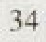

*Ttie la nur market*

Table 4.A

**Changes in employment by work stntus'** '

Perceritage Change 10(JOs) Perccniogc Change' (000s j



»r



Self played 2:9. 94 1.8 58

:Full-time .1.5 39. I..6 4 I

Pan-time :9.2 34 2'.9 17

###### demand side. the greater availability of certain types of work—such as temporary contracts, part-time work and

.self-employment—m ay make it easier for firms to match labour demand and supply. Self-employment may improve flexibility by enabling firms to enter into a contract for services rather than a contract for employment; and part-time jobs and temporary working arrangements are easier to match to specific production requirements. And on the supply side, the greater availability of different working arrangements may increase flexibility by drawing people into the labour market who would be unable or unwilling to undertake full-time, permanent work.

Since 1979, the percentages of total employment accounted for by part-time working and self-employment have increased .from l99a to 289a and 8% to 13% respectively. Consistent data about temporary work are available only from 1984 and indicate only a modest rise in the period to 1991. However, over the three years to spring 1995, the fraction of jobs accounted for by

employment ffi; 1.2

zu i.i 270 temporary workers increased sharply, rising from 5.5%

»••: •^•- to 6.9% (see Table 4.A). Unfortunately, since the data do bL To. s imlud ptoplc o govrm .i *.':' •i ',•„ {„ " not adequately cover the previous recession, it is difficult ""“ to know whether this type of hiring pattern is normal in

###### the first few years of a recovery.

These changes in the composition of employment over the past decade are likely to have improved labour market flexibility and may have lowered the United Kingdom’s .natural rate of unemployment. As discussed in Section 3, more flexible employment patterns should

###### improve the.ability of firms to. work at—or close to-fuI1 capacity, and hence firms should be better able to meet increases in demand for goods and services without coming up against capacity constraints. Other things being equal, this would imply a greater degree of

.downward pressure on wages at any given unemployment rate. So the economy’s natural rate of unemployment may be lower today than it was in the early 1980s, even ,though its level remains uncertain.

Consistent with these developments in the labour market, there: is some evidence that employment has been more responsive to changes in demand during the most recent economic cycle than..it was in the previous one. In particular; :total'emp1oyment began. to rise only four

qu rs after the 1592:troiigh in .GDPi whereas: output iticreased for eight quarters following the 1981 trough Nfore,‹»iiployrnent started to rise.



Iitt1aii‹›n Rcg‹›rt: August 1 afis

## 4 3 U e lo ent

In line with the above indications of a weakening in



.labour demand, the US measure of unemployment increased by 28,000 between winter 1994/95 and spring

 1995—its first quarterly rise for over two years. The claimant-count measure of unemployment has, however,. continued to fall; but the speed of decline has slowed markedly (see Chart 4.10). In the second quarter of.this year, claimant unemployment fell by just 33,600, one quarter the size of the fall in 1994 .Q4 and about half as much as the reduction in 1995 Q1. There is also evidence that the most recent declines in claimant unemployment have .been less widespread: in,June, both male and female unemployment rose in a number of regions. The .national unemployment rate,remained at 8.3% in June, unchanged for the third mpnth in succession.



The slowdown in employment demand has coincided with a reduction in the rate at which people have left unemployment. The number of people joining the count as a proportion of total employment (the inflow rate) has fallen at a fairly steady pace since 1992 Q4, whereas the number of people leaving the count as a proportion of total unemployment (the outflow rate) fell slightly in the second quarter of 1995,.after rising.during 1993 and 1994. According to the CSO, the changes in the criteria for eligibility for incapacity.benefit, which were mentioned in the May *Report,* have not yet had.a sizable impact on claimant unemployment numbers. The new medical test for incapacity benefit, introduced in April, is likely to boost.the:claimant eottnt towards the end of the year. as some people lose entitlement to the benefit and switch to claiming unemployment benefit..

This switch will have important implications for the interpretation of wage.pressures. !Any such increases in the claimant unemployment.cohnt,..where the .i.ndividuals continue to consider themselves as being unable to work, will tend to exaggerate the .extent of downwayd.pressure on wages. Given.such distortions, the LFS is likely to

provi’de a better tmpre!’ssion oI actual !changes in

unemployment„since it.is.based on a survey of households, not people clâiming unemploymelit benefit. The:LFS defines people, as utiemploJed if they:

Wltñout a job,:avai!1ab1e to.start Work.in the tw;o we'eky. following their LFS interview„and if they/have **either** tooked for Work in.tire four wesks. pnor:to interview or

.are waiting to start a job tliey .hava aJready-obtained.





**Unemployment peaks'•›**

e4y.44

Unem *\o* ment and wa es





- 8

4 — 0 + s' 8

Souwc: key/ w¥n/ C«zrr‹c.

Between 1993 Q1 and the first quarter of this year, the unemployment rate fell by 2.0 percentage points and the level of real average earnings (deflated by the RPI) increased by 2.1%. As can be seen from Charts 4.11 an‹i 4.12, in the previous cycle the unemployment rate fell by 3.3 percentage points in the two years immediately following its peak and, over the same period, real average earnings increased by 7.3%. There are two key considerations that help to explain the more

muted wage response in the 1990s: first, the natural rate of unemployment, whatever its precise level, may be lower now than it was in the 1980s; and second, the decline in the United Kingdom’s activity rate up to winter 1994/95 may have exaggerated the speed with

which the economy was approaching its natural rate.

{a) me peas in unemployment baies' wire' in 1986 Q3 and 1993 gl .

Chart d.12

**Real average** earnings‹•›

PeaL:in unemployment mie â' 100





8.



4





.Chart 4.13

***MAmatch* iri:the labour market**



###### There are a number of reasons for expecting the United Kingdom’s natural rate of unemployment to have fallen

"' over the past ten years, although it is impossible to

###### °• observe directly. As well as the impact of changes in the

i , composition of employment in the UK labour market

###### p discussed in Section 4.2, there is some evidence that the degree of mismatch between potential employees and

" employers seeking to fil1 vacancies (in terms of both '°° geographic distribution and skill requirements) has

•• diminished since the 1980s. As jobs and potential

›‹ employees become better matched, there will be greater

„ .competition between applicants to fill advertised jobs and hence, at any given level of unemployment, there

###### “ will be .greater downward pressure on wages. Although mismatch cannot be monitored directly, there are a number of regional indicators that can be used as proxy measures. Chart 4.13 shows that the regional dispersion of unemployment fell sharply in 1989 and 1990, and is now at its lowest level for more than two decades. These

^ measures.suggest that the degree of regional mismatch in the labour market has lessened.



Anqther factor that may influence wages is the speed with which an economy approaches its natural rate. If an economy is rapidly falling towards its natural rate of unemployment; upward pressure on wages may develop before.the ac.tual rate of unemployment moves. below the

. .

n8tiiral rate. Chart 4.11 indicates that unemployment has

" . falle.n at similar rates in the most recent two recoveries.

###### Tile falls iq the unemployment rate:over the past two years may give:.a misleading indication of the speed with. which.tnp U.nited Kingdom is.currently:approaching its

.37.!

lnllation Rtport: Augusi I *795_



L ntnplsnizz andinau ih t



i lcfi-h:ind .sciile J





RPIX inflation and employees’ expectations of wage increases

###### natural rate. Between winter 1992/93 and spring 1995, the declines in both the LPS measure of unemployment and the claimant count exceeded the recorde‹J increases in employment. The percentage of people aged 16 and over who are neither employed nor actively seeking work (the inactivity rate) rose up to winter 1S94/95 (see Chart 4.14). As well as an increase in the number of discouraged workers, three longer-term considerations help to explain thfs development: the rapid expansion of tertiary education; large increases in the number of people claiming invalidity and sickness benefit; and an increase in the proportion of men taking early retirement. If these individuals were not actively seeking work prior to their leaving the workforce, then the fall in the unemployment rate over the past two years may exaggerate the eKtent of tightening in the labour market and, hence, lead to an overestimation of the extent of upward pressure on real wages.

4 5 i e nd w e e ect t s

Despite the fact that movements in real wages are the key to an individual’s: standard of living, wage bargains in general determine *nominal* wage increases. Prices are therefore likely to affect page negotiations, both through the inflation expected.over the period of the wage agreement, and through any adjustments for previous differences between actual and expected inflation.

Evidence of this can be seen in wage agreements monitored by the CBI: .in the period since August 1994, inflation was the.factor most frequently cited by firms as having an important. influence on their wage agreements. Hence, in considering the pressures on wage5, it is. essential to monitor inflation expectations.

' All of the available surveys suggest that inflation expectations fell markedly between the fourth quarter of

* + - 1990 an‹i the beginning of 1993, in line with the dow‘ntum in actual inflation. Since then, inflation

‹ expectations have been broadly unchanged. The second-quarter,average of **Gallup’s** monthly Survey of

, employees showed a mean expected.i.ncrease ion prices over the next twelve'ifionihs of'4.the, well above.the

###### , June headlineirate of inflation/of’3.5.&».; but only..slightl!y above the.tax. and price.meaeure. ñf inflguon., Similarly, the latest Barclays Basix.Survey indicates that general ‘secretaries.of TUC-affiliated.trade:qnions.expected ptices to incmase by 3..9â over the twelve montlis to June 1'996. Workers' wage expectatioqs„ however, Frere below their expectations of price briefcases, iinplyfng that



theiy, **are projectin**.**g** real w. ages **té fail;** ..wage **expectations** .



*The I'abour.. market*

averaged 2.5&a in the second quarter, up from 2.3% in



.Q1 (see Chart 4.15).

## — • 4 6 P du ti if a t e os

, Part of the explanation for the limited pass-through of

, higher import prices to retail prices over the past twelve

, months is that increases in the costs of physical inputs have been offset by strong productivity growth and relatively small increases in average earnings. The

' extent of these offsetting cost developments appears to be diminishing. Manufacturing productivity increased by 3.59a in the year to 1995 Q1. down from 6.1to in the

l9BO8J. #2 :8J’’’M ’85.’:86 87 88 89%0 9l 92 93 94 95

Chart 4.17

Unit wage cost gron'th





**Table 4.B’**

Unit viage costs and their components

year to 1994 Q4; and underlying average earnings growth in manufacturing rose to 5%. As a result, unit wage .costs rose by 1.7% over the year to 1995 Q1, following a fall of 0.5% over the year to 1994 Q4.

> Furthermore, data for April and May indicate that the

„ growth rate of unit wage costs continued to rise, with

.annual increases of 2.4% and 3.0% respectively.

The turnaround in productivity performance and average

earnings growth has been less marked at an

economy-wide level. Figures based on employment data

from the workforce-in-employment series suggest that

.productivity growth slowed to 3.0&o in the first quarter of this year, down from 4.ldc in 1994 Q2 (see Chart 4.16). Since average earnings growth has been stable, unit wage costs increased by only 0.She over the year to

1995 Q1 (see Chart 4.17 and Table 4.B). Figures derived from the LFS employment data present a similar picture: productivity growth fell to 2.7% in 1995 QI and unit wage cost growth increased to 0.9%.



# 4 7 S a

, 199.2



' ,'sQ›2

-II.5; -2.4 1.9. 5.9 4.0

2:3’’ ’ -’:0 53 3d 01’

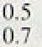

0.2

30

3’:j

’0.4

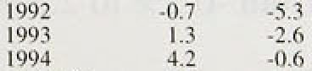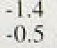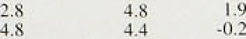

3.8

4.

6.3"!

4.5

Thee growth rate of the demand for labour fell .in the first half of this year. Evidence from total hours worked and the composition of hiring suggests, however, that this deterioration will be temporary. Reflecting the weakening in labour demand, the size of monthly

as diminished sharply.



##### There are still very few indications of upward pressure

that unemployment is still above its natural. rate: Past changes in the composition of employment suggest that the .United Kingdom’s natural. ate 9f unemployinent may be.lower today than it was in the previous recovery, so ñownviard pressure on wages qpuid .persist for.some time.



' 39



I nipurt prices a nd Ilie sterling FIR I

5.1 External influences

###### The May *Report* noted that sterling had fallen sharply„ import prices had risen and:commodity prices were edging upwards. Data released since then show that import prices have continued to.increase strongly, but

" ›• that commodity prices. have eased; sterling’s effective.

„_ exchange rate index Atas fallen a little further.



Between 4 May and 28 July, sterling's effective exchange rate index fell by I.2%, from 84.4 to 83.4, leaving it around 69r below this year’s peak reached on 24 January. Although this .depreciation is likely to produce higher import prlces and push up inflation in the short term, the long-run impact on the UK price level will fiepend on the reasons for the fall and any domestic monetary policy response, as was pointed out in the May

 *Report.*

Charl 5.2

**Import price** indices



— 110

###### The short-run i.mpact on import prices,of the pound’s fall can already be seen. In the three months to April, the sterling effective exchange rate index depreciated by 4.6% and non-oil import prices rose by 3..3@o. Taking a. slightly longer-term perspective, the pound depreciated by 5.3% over the twelve months to April, while non-oil import prices increased by 10.7â«„(see Chart 5.1).

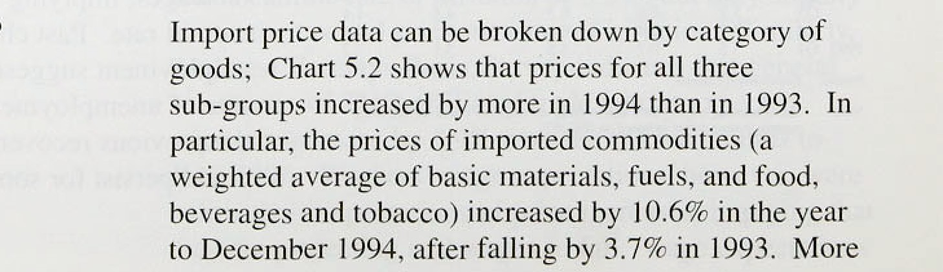Although trade.data are often revised, so that .the figures can.only be used as a rough guide, the fact that over the twelve. months import.prices went!,up..by more than sterling fell reflects the increase. in the price!of.tradab1e goods.relative to that of.non-tradables. Consistent with the picture of rising.relative prices for,traded goods, producer output! price inflati9n.in the. G.7 countries.(otñer than the.United Kingdom) .i.qcreased ffom -0.2% to 2.5.% over tire year.to.March’1995.:.





recently, there has been growing evidence that the strength of world commodity prices. has fed through into

higher prices for imported semi-finished

manufactures,

Tabie 5.A Import prices



3 h h 12-month cfi

.Oc\: Can. Apr: ION. Jan. Apr,

###### which make up about a quaner of UK imports. As can be seen from Table 5.A, in the year to April the prices of these goods increased by 18.5%, well above the rise: in commodity prices over the same period. This implies either.that other input costs have also risen strongly or

that the exporters of these goods have taken advantage of

Cammoditics t•› -3:4 5:2 3.7 'i.I 10:7 12.4

 4.T 16.2 18.5

Finished

mariufzic\ules -3.2 6.’7 2,3 2.6 8:'i 7:4



Bounces:' CSO.and Bank fEngiana.

Jfie *dci* niiion &comm.odiIies.used here inclv* b'zsir materials. FM Iy, and

‹by Ei*§*ums re)aé to* percentage changes between monifii arcmgc6.

###### the improvement in demand conditions to increase their margins.

Given that the sterling effective exchange rate index fell by 3.3% in the second quarter of this year, following a decline of 2.1% in the first, import prices are likely to have continued to rise in 1995 Q2. Trade data relating to non-EU countries are available on a more timely basis than those for the whole world and indicate that non-oil import prices increased by 2.09r in the second quarter.

Are import prices likely to continue to rise? Leaving aside the prospects for the pound, this question is probably best answered by dividing imports into two categories: basic commodities and manufactures.

###### The percentage of UK visible imports accounted for by basic commodities fell from around 45a in 1970 to l79r in 1994. Commodity prices nevertheless continue to have significant direct and indirect effects on import prices, as they affect the prices of semi-finished and finished manufactures. As a result, movements in commodity prices contribute to short-run cost pressures in the supply chain.

World commodity prices fell in the first six months of 1995. The Economist index—which uses a set of weights derived from OECD imports—indicates that

.sterling-denominated non-oil commodity prices fell by ñ.4% between January and June, following a 28% rise in the twelve months to January. However, because of differences between the OECD as a whole and the United liingdom in the composition of imports and use of commodities, the Economist index does not accurately reflect the way in which commodity price changes affect tñe UK economy,. In particular, it has exaggerated the impact hoth of the.rise in commodity prices in 1994 and the fall.in 11!995, To gain. a.better view, the Bank has d’eve1oped its own.demand-weighted commodity price

!lndsX; 1 which takes account of ltte fact that UK inflatioiiary pressure is affected by changes to the prices



1nnatienep‹R in: Augu›i 1995

###### of commodities produced domestically as well as price changes of commodities that are imported.

Agricultural products, which make up around 409a of the Bank’s index, are one of the most important categories

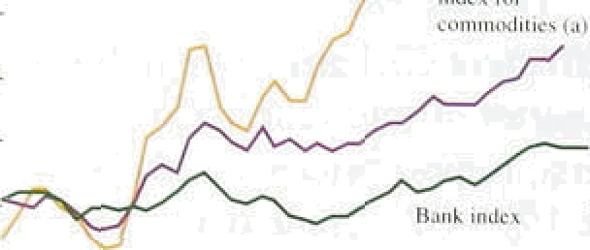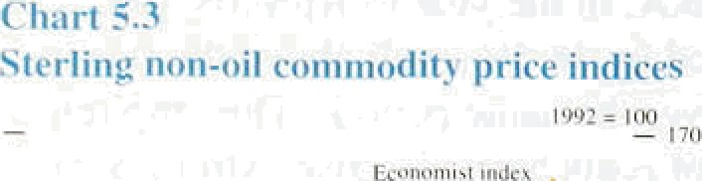

- l?0

—

— 110

of domestically produced commodities. Because of the price support system within the Common Agrieultural Policy, the prices of these agricultural goods have also increased as the pound has depreciated. This has occurre‹i because price support payments are determined fn Rcu and then converted to a Member State’s currency using the so-called ’green’ rates of exchange. As was mentioned in the previous *Rep.ort,* this system has had an



###### whole, since weak-currency economies have devalued— leading to an increase in they support prices—more often than strong-currency countries.have revalued.

This inflationary bias may no.w.have come to an end; a reform package agreed among EU agriculture ministers on 23 June led to five EU epuntriesl revaluing their green

.rates of.exchange, on the understanding that .farmers in those countries would receive transitional relief to.help offset any reductions in support prices.

**Chart** S.fi

Crude nil price‹•'



— I4

The Bank’s index indicates that the growth rate of sterling-denominated non-oil commodity prices fell back in the second quarter, after rising quite sharply in

1995 Q.1 (see Chart 5.3). When oil prices are.included, the Bank’s index .increased by 3.8&n in 1995 Q1 and by less than this in Q2. After rising nearly 9& in April. dollar-denominated.oil prices fell back in May and June, (see Chart.5,.4) and futures contraets suggest that prices are expected to fall slightly over the rest of the year. In addition, futures markets suggest that the prices of most base.metals are expected to rise by less in 1995 than they did in 1994.! Although much ,of the.recent fall..in the price. of oil has,been caused by OPEC countries exceeding their production.,quotas, the weakening of other,commodity prices particularly metal:prices— probably reflects.downward..reyisions to forecasts of. world grow,tii, following signs of weaker than expected output:in.the United.States.and.,Japamin 1995 Q1.



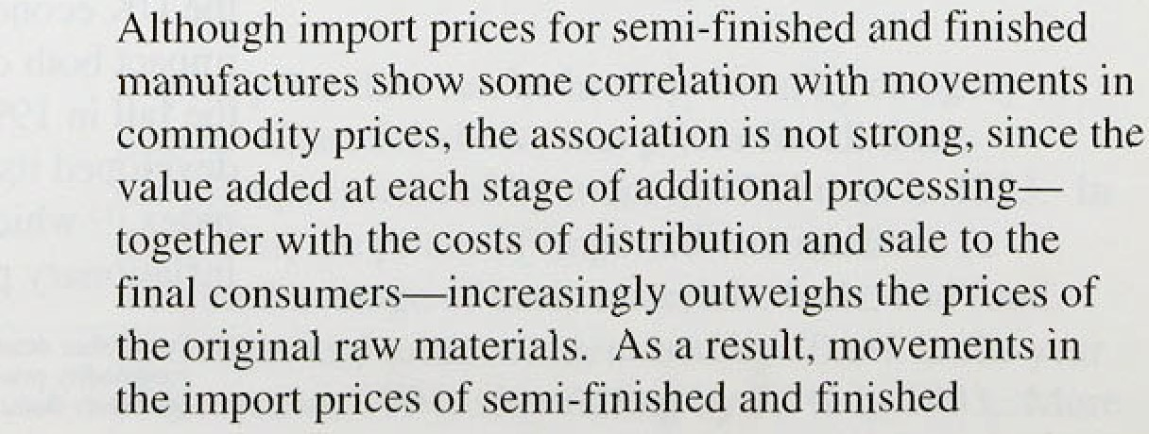

###### manufactures are generally less volatile than commodity prices. Recent research using data from the United States and the United Kingdom indicates that producer

.price margins tend to rise during economic recoveries

and fall during recessions. Given this evidence, and the fact that G7 real GDP increased by 1.3% in the year to 1993 Q4 and by 3.3% in the year to 1994 Q4, it seems likely that the prices of semi-finished and finished manufactures will continue to rise during the rest of the year, even if commodity prices fall.

*Tlte* pass-thrfJflgfi *of hither imyon yi‘ic’‹•. to i etail yrices*

As was pointed out in the May *Report,* if monetary policy is not tightened in response to an exchange rate depreciation, there will be two channels by which higher import prices feed through to higher retail prices. First, there will be a direct impact on the prices of imported finished consumption goods and second, there will be an impact from more expensive inputs. which will eventually be passed along the supply chain to producer output prices and then to retail prices. But neither of these channels is as rapid as the change in import prices in response to movements in the exchange rate.

Since the non-traded goods sector adds value to imports of finished consumption goods in the process of distribution and sale, the retail import is, in effect. a different good to that which lands at the dock. In consequence, its price should be expected to change by an amount proportional to the share of the imported component in total unit costs. Furthermore, importers’ mark-ups are sometimes varied in order to insulate consumers from changes in the cost of the import (if, for example, it is expected to be temporary), thereby dissipating the impact of currency depreciation on retail prices. Hence, although around 15% of the goods and services included in the RPI consists of imports sold direct to the consumer, a 19 rise in import prices will be associated with a rise of less than 0.159c in the RPI,

.unless mark-ups are increased.

###### The pass-through of higher import prices along the supply chain will be even slower and proportionately smaller, since the share of imported inputs in total costs is .likely to be less for goods manufactured in the United Kingdom than.for imported finished consumption goods. This suggests that; over the short term,. any rise in retail price.itrf1ation wfll reflect.only higher prices. of finished etinsnmptio n goods,.unless the import price increases trigger second-round wage and price increases, straight away. Hence, ster ng's,S& depmciation in.the first half



nfaionRcpou: Augunl995



of 1955 is unlikely to increase the retail prices index: by more than 0.9% (I 3% of 6&) over the short term, abstracting from second-rou nd effects. The fact that UK domestic inflation is low gives added weight to this argument, since retailers’ scope for altering their

mark-ups depends on their scope for changing the relative prices of final goods. When the prices of domestically produce‹i goods are increasing rapidly, it is fairly easy to raise the retail prices of imported goods; when domestic inflation is low, however, relative price changes are conspicuous. So if the price of a domestic substitute has not changed, the scope for altering the retail import price is limited.

Higher import prices will also affect the prices of domestically produced goods that use imported raw materials or semi-finished manufactures as inputs. In the United Kingdom, about a.quarter of domestic demand is accounted for by imported materials, and therefore the maximum impact of this yeat’s 6% depreciation of the pound would be a l.59r increase in the level of the RPI, before taking account of

second-round wage and price effects. However, even without a tightening of monetary policy, it could.take several years before the increase in import prices is fully reflected in retail prices.

5 2 b t

In an accounting sense, a firm’s profitability its return on capital is jointly.determined by its ratio of. output to capital and its price margin. Nominal gross trading profits.of companies in the economy as a !whole fell by 3.8,% between 1994 Q4 and 1995! Ql ; fo1lowi!ng four successive quarterly increases, but were 9.4% higher than in 1994 .Q1. Although it .is possible to,draw inferences about movements in margins Koi

.manufactu!ring and retai1i.ng, there are very few.data! relating to the rest of the economy. Those.there.are suggest,that the fall in.profitability in the first quarter was.the.result of strong,.increases i.n,costs. (particularly

.import prices) .which were not,matched by similar increases, in domestic outpUt prieles. Capacity utilisation rates—which may have an influence.on.both firms' investment plans and their setting of ñiargins ha.ve

.continued to rise. ’



domestic.manufacturing inputl **prices** (materials and”



**.Chsrt5.5**

**Producer prices and import prices**

_ Pcrpcn change on ihroe moults earlier $







l9s2 '93 ' 94 95

**Table 5.B**

**Rstes of change of manufacturers’ costs**

Yeer-on-year pcrcen\agg chcrtgcr

199# 199a



**:Cos(s**

in 1994. Since then, there has been a slight reduction in input price pressures. As can be seen from Chart 5.5, the rate of short-run input price inflation fell between January .and June, leading the annual growth rate to fall

to 10.2%.

###### Despite the strong increase in input prices, the annual

rate of output price inflation has only increased by

2.3 percentage points since its recent low in July 1994, reaching 4.2% in June. Part of the reason for this limited pass-through is that firms have been able to use

improvements in productivity to offset the impact of higher input prices. In the year to 1994 Q4, manufacturing productivity increased by 6.1% and unit wage costs fell by 0.5%. However, as discussed in Section 4, this lcyclical improvement may be coming to an end: productivity growth fell to 3.5% in 1995 Q1 and unit wage cost growth increased to 1.7%.

Input-output data suggest that, for manufacturing industry as a whole, unit labour costs account tor around a half of total variable costs: materials and fuels (including semi-finished manufactured imports) constitute approximately a quarter; imports of finished

:Un ‹ wag;e' Co8.IB Ma‹e'risIs'atul Fuels tiucliiding se'mi-finiihed



-0.2 -.l i4 I.7

manufactures represent a tenth; and the remainder is accounted for by services. These weights can be used to provide a rough guide to movements in total costs:

Services 2i1. 1.6 1:5 0.5

**6oucw:f5OandBunR‹JEngl@0.**

Table 5.B shows how the costs of these inputs have

changed in recent quarters. The principal source of price pressures has been .the cost of physical inputs to manufacturing: in 1995 Q l, material and fuel prices were 11.69c higher than a year earlier. and the prices of imported finished manufactures were up by 9.9%. After including contributions from unit labour costs and service inputs, a simple measure of total manufacturing

.costs shows an increase ofjust under *5Po* in the year to Q1, up sharply from around 29 in the year to 1994 Q4. In contrast, output prices rose by 3.6% over the four quarters to 1fi95 Q1, implying that the mark-up of manufacturing output prices over input prices fell over the year. This fall followed five quarters in which output price inflation exceeded the annual change in costs.

Will margins continue to be squeezed? On the costs

,side, !it seems unlikely that pressures will ease significantly in the.1short term. Although commodity prices have fallen re:cent1y, this is likely to be offset by the continuiitg e8eets of sterling’s depreciation and the slackening. of productivity:growth. So the key to how margins develop will be movements in on'tput prices.

* ' Som‹avhat.surprisingly,,shon-term inflation indicators

###### 1 ' eugg6St thgt outpnt pnce pressures hnve moderated this







hlant jfacturers ' nutput prior **iyflatinn**







I99*. *).) 9* 9S







Chart S.6

Survey **indicators ut** producer **output prices**

Arr rem. sr*«infilly zdjuxicd (a I Per ccni, ie onally. edjusied tb}

 — 80

*-*



- 70

year. The three-month annua!lised rate of change.in seasonally adjusted output prices fell from 7.6& .in January to 3.5% in June. To sorrie extent; this ‘slowdown’ has been erratic: Output prices excluding food, drink, tobacco and petrol are less volatile and generally provide a better indication of the trend. The short-term inflation rate of this measure increased during the second half of 1594 and, since Oetobef, has averaged around 5&• on an annualised basis.

Gross output price inflation, which includes the prices of transactions between manufacturing firms, rose to 5,4% in the year to May—up from a recent low of 2.2% in the year to July 1994 (see Chart 5.6), suggesting that pressures at the intermediate stages of the supply chain have intensified. Evidence .of increasing price pressures in the manufacturing sertor can also be seen. in the ratio of.input to output prices which, although historically quite low, has risen to its highest level for four years (see Chart 5.7).

Survey evidence is mixed. The strongest suggestion that output price inflation will continue to rise is given by the Chartered Institute of Purchasing and Supply (CIPS).

Survey. This asks about the prices of purchases each. month compared with one month earlier and should, therefore, move in line with .gross .output price inflation. In luly, the in‹iex was 72.0, well above the 50.0.level that is associated with .no change in prices (see

Chart 5.8), indicating that price pressures remain strong. Purchasing managers also continue to report that delivery times are lengthening, which may indicate some inflation pressure. Similarly, the CBI’s July Survey reported that the number of firms expecting to increase prices exceeded those expecting to .reduce them.,

1. However, the CBI Survey pointed to a reduction in price pressures since its January Survey. In July, the positive balance of firms expecting to increase domestic prices oyer the following four months was .l.8& —.in line with



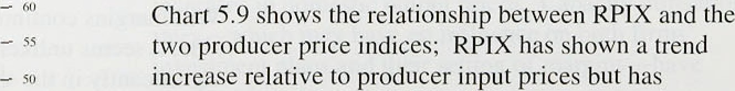i0 —

###### - 4s generally movéd in.1ine’with producer output prices,

10 -’.40'’:

92 01 M 93

Sources: carars) Chanced lnuiiuct ofi Pvitt*iing and'Sugply.

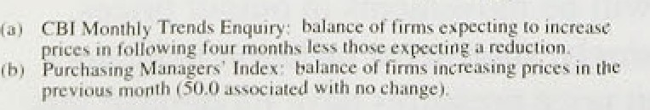



output prices between 1985 and 1992, and that the recent strength of output prices has not yet restored the ratio

between the two indices to its long-run trend.

Hence, it



**Ratio of RPIX to producer prices**

- 170

seems likely that not all of .the increase in producer output price inflation will be replicated in higher RPIX

inflation.

A firm’s profitability may also be influenced by its degree of capacity utilisation. Increases in aggregate capacity utilisation imply that more and more firms are operating at or near their full capacity, bringing forward the point when margins are raised. According to the latest **CBI** Quarterly Trends Survey, the proportion of

###### '" manufacturing firms working below capacity increased

|  |  |  |
| --- | --- | --- |
| **“'•'inp•' 'in** | — '" | slightly between April and July but remained close to its |
| — | — i« | lowest level for more than five years, suggesting that any  squeeze in margins brought about by higher costs is  likely to be temporary and will probably be offset by |
|  |  | higher output prices. |
|  |  | Manufacturing exporters have fared better, since |

- 90

' tg7s ’ 8O g OO. 99

profitability has been supported by the fall in the pound.

Over the year to 1995 Q1, non-oil export prices increased by .6.69 , well above the estimated increase in costs that UK manufacturers have faced. Export margins, therefore. probably increased over the year.

Combined with the previously noted high capacity utilisation, this suggests that profitability among UK exporters increased sharply over the period.

*Retailing*

Differences between the unit wage cost increases in manufacturing and retailing are relatively small at present. As a result, the rise in the price of physical inputs—through higher manufacturing output prices and higher .prices for imported goods—has dominated increases in retailers’ costs. In the year to 1995 Ql, RfiIY inflation averaged 1.9%, while retailers’ costs are estimated to have increased by just under 4%, suggesting that their margins fell over the year, continuing the downward trend seen over the past two and a half years.

*Utilities*

Unlike other sectors, where the degree of competition

###### detel ines each firm’s pricing strategy and profitability,

,utilities.generally have to charge prices within limits set by official regulators.! Hence the profitability of utilities

, is determined by:!their ability to.keep thei!r cost increases **below** then allowable price **change.** The .latest available infonmtion. suggests that.utility price.increases.may

##### : haYe’.less'pf an tmp ct onlRPIX inf1auon.this year than



Infla\ion R zj: Au;gurt 1995

last. The contribution made by both electricity and gas fell in April, as the effects of the introduction of VAT on domestic fuel and ppwer dropped out of the

twelve-month calculation. In addition, undet the new price formula set by OFFER, electricity distribution charges are to fall by 11&«-17% in 1995-96, and by 109a—l3&a in .1996›-97. British Gas is proposing to introduce a slightly lower tanff for those customers who pay their bill within a few days of receiving it. In order to comply with OFTEL’s pricing formula, British Telecom must cut the .average price of telephone calls by 3.5% this year, though price controls over line-rental charges have been relaxed. And postal charges have been frozen for at least the whole of 1995.

However, .in April, water charges increased by 6.2&o, coiisiderably above the current rate of **RPIY** inflation, But OFwAT has reduced the.allowable increase in water charges in this financial year from the November RPI inflation rate plus Sdn to November in(lation plus l.4&o.

53 S

Import pricles rose strongly in the first quaver of this year, both in response to the depreciation of the pound and as a r,esult of higher world .export prices. In the second quarter, import prices are likely to have increased further, as sterling continued to depreciate. However, the speed of the pass-through of.higher import prices into higher retail price inflation will vary from product to product, depending on the.extent of processing in the supply chain and the degree of price competition. As expected, there is growing evidence that firms have chosen to absorb some of the rise in import costs in their profit margi!ns. However; other costs in..the manufacturing sector also appear to be increasing, suggesting that twelve-month output price, inflation wi.11. continue to edge upwards. But the exteui to which higher output pri:ces feed through to retail pricés will iiepend .on the stance of UK monetary policy and, In the long ran, on the .reasons behind sterling’s depreciadon.

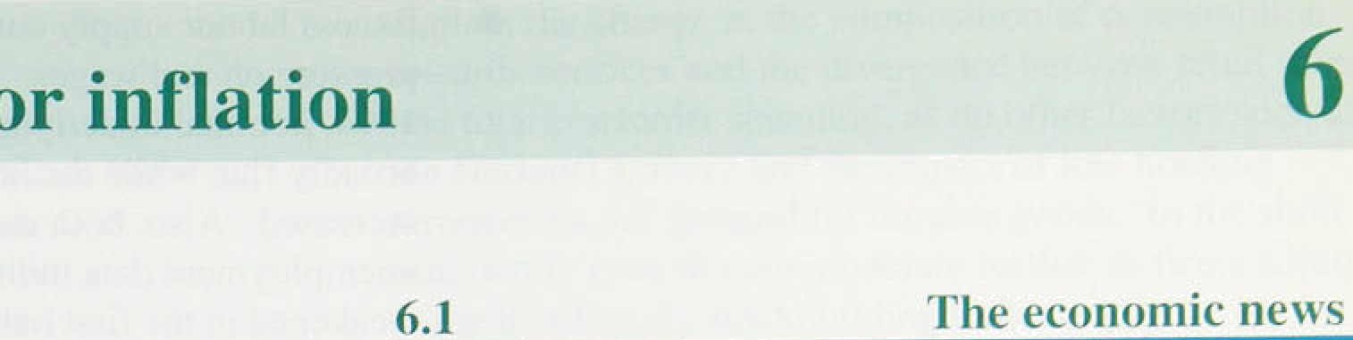

##### The Bank’s assessment of the inflation outlook takes account of the main economic news reported in previous sections:

RPIX inflation has been broadly stable since the May *Inflation Report,* but RPIY inflation has edged up, from 2.0% in March to 2.3% in June, in line with projections in the May *Report* (Section I).

Narrow money (measured by notes and coin), broad money and credit have all grown strongly. Bank spreads have narrowed. Corporate sector borrowing increased rapidly in the first half of 1995 (Section 2).

The exchange rate is slightly lower than at the time of the May *Report.* .Futures prices do not imply a recovery; indeed, bond yields suggest sterling is expected to fall a little further over the next ten years. Comparing conventional and index-linked gilts, expectations of inflation in five and ten years’ time have increased, but they have fallen for shorter horizons (Section 2).

Most activity indicators have been weak since the May *.Report.* Estimated GDP growth in the fourth and first quarters was revised down; retail sales volumes in the second quarter were broadly flat and so probably was industrial production. There were signs .of an involuntary build-up of stocks of

,finished goods in Q1 and domestic demand fell. Both the .housing and construction markets weakened, too. But non-oil GDP expanded at a rate a little above trend in the second quaner, as the output of services more than made up for the weakness of industrial production (Section 3).

Trade performance was strong in.the first quarter, hand the outlook.continues to.be good, because of ltte lower real exchange.rate. Overseas demand many. be lower than previñusly expected; but this is

:qnlikely to outweigh.the exchange rate effect

:(Section 3).

Excess labour supply continues to put downward pressure on redl wages. Since the beginning of 1994, nominal underlying earnings growth has been broadly flat, yhile the headline rate of inflation has increased. Also, both employment and unemployment data indicate that labour demand weakened in the first half of this year, suggesting that the speed at which the labour market is tightening has slowed (Section 4).

Price pressures at the early stages of the supply chain have increased since the May *Report,* largely as a result of higher prices for imports. This has not had a major impact upon domestic producer output prices as yet, because firms have absorbed some of the rise in costs in their domestic profit margins.

However, other cost pressures in the manufacturing sector also appear to be increasing, suggesting that output price inflation will rise further, leading to higher retail price inflation at least in the short term (Section 3).

* 1. **The current economic conluncture**

The economic news reveals a marked 'dual economy’. Since last autumn, the output of services has grown strongly. but the output of goods has not. Yet the May *Report* stressed the dichotomy between the sectors producing internationally tradable and non-tradable goods and services. How are these two pictures to be reconciled?



Chii rt 6.1

°iD

Two facts suggest a resolution to the puzzle. First, domestic demand for manufactured goods—for both consumption and investment—is more sensitive to changes in total domestic demand than is domestic demand for services. Second, domestic demand for and domestic output of services move closely together, so that the direct contribution o( sewices to net exports is small. Hence the interpretation of recent output data is that in manufacturing, and industry more generally, a fall in domestic demand has offset a rise in expori demand. In the services sector, domestic demand has continued to grow, bolstered by an indirect demand for those services related to the export of goods, such as transport and communications. The persistence of the exchange rate fall, combined with continuing weakness in consumption and the housing market, suggests that the ‘dual economy’ is likely to continue. The price of tradables relative to non-tradables has increased (Chart 6.1); so has the price of goods relative to services. This helps to

explain the change in the composition of consumption towards services and th e diYergence betweell retail sales and total consumer spending, as do other factors such as the National Lottery and the impact of low housing turnover on the demand for durable goods. In the short run, output growth may moderate further as firms adjust to the involuntary stockbuildin g indicated by the Ql national accounts and the July CBI Quarterly Industrial

###### Trends Survey. By next year, however, this

disinvestment in stocks should have run its course, and

personal consumptio n is likely to return closer to trend

.growth.

At first sight, the strength of employment and pay in manufacturing relative to services does not fit comfortably with the other evidence. But the growth in employment may be a delayed reaction to the increase in

demand last year. The relative pay of workers in

.manufacturing has gone up largely because average service-sector pay has been held back by small pay increases in the retail industry and limits on public sector pay bills.

###### The inflation outlook depends on the answers to three

questions:

* 1. will output growth continue at its recent pace?
  2. will inflationary pressures in the tradables sectors have a second-round effect on domestically

.generated inflation?

###### will the more rapid growth of the money supply and credit lead to more rapid increases in aggregate nominal demand?

The conditions for increased business investment—high profits, emerging capacity constraints, forecasts of continued demand growth—are still in place in many industries, although the ‘dual economy’ means that some plarts of manufacturing, construction and the utilities are unlikely to see much of a pick-up. Consumers may already have adjusted their spending in the light of tax increases in the spring, and trade flows are still adjusting to the lower real exchange rate. But it is important to acknowleldge tke downside risk to activity, particularly given.the!weaknesslof domestic demand in the.first half of.this year. The possibility of a pause in growth led by the,continuation of destocking cannot be ruled out, esperidfy if there turns out to have been further iñ'vol1intary stockbuilding in the second quarter.

.Buainess,cenfidence about future sales has fallen.,

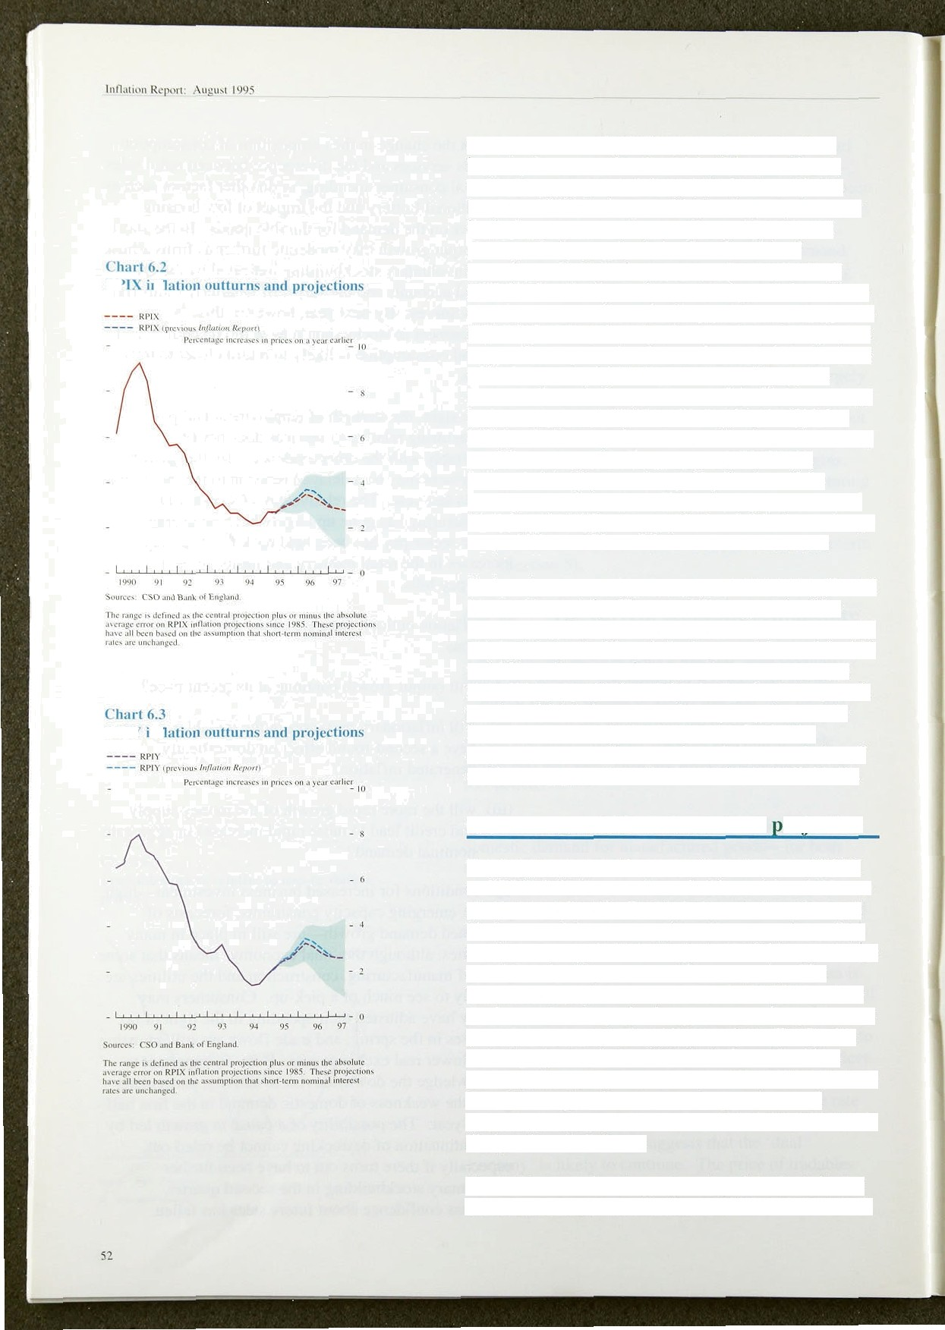

lt I it

Cost increases. derived directly and indirectly from import prices, are at levels which, if they continued, would be inconsistent with the inflation target in the long run. With the impact of higher import prices now beginning to be seen in retail prices. and more cost pressures in the supply chain, there is a risk of

second-round effects from the adverse supply shock brought about by the exchange rate depreciation. Firms may try to restore domestic margins by increasing prices instead of bearing down harder on costs, and employees may seek compensation for an adverse shift in the terms of trade. If this were to happen, transmitting price pressures from the buoyant sector of the 'dual economy’ to the weak sector, there would be a danger of higher inflation in the very short run—and in the medium term, too. if second-round effects were expected to be accommodated by monetary policy for fear of the consequences for output and employment. This would be aggravated if there were a further fall in the exchange rate, which would be a risk in such circumstances.

Such a situation would arise only if money were allowed to grow too rapidly. The recent faster growth of the monetary aggregates suggests a pick-up in the growth of nominal demand, although the increased demand for M4 and M4 credit seen so far may reflect no more than a reshuffling of portfolios. It is whether the faster growth persists which is important. A temporary increase in monetary growth could reflect borrowing by the corporate sector to finance unintended accumulation of stocks and higher precautionary saving by individuals.

* 1. **The Bank’s medium-term roieetion**

The Bank’s medium-term projections for annual RPIX and **RPIY** inflation are shown in Charts 6.2 and 6.3. As usual, they reflect the Bank’s judgment about the most likely, or modal, outcome, given the assumptions of (a) unchanged official UK interest rates and (b) an exchange rate determined by uncovered interest parity. The forecast horizon has been extended from eight quarters to nine, so that the projection goes out to the quarter two years from this *Report's* publication date. The Bank’s central projection is that RPIX inflation will still be somewhat above 2'/›Tr in two years’ time, although there is a wide margin of error around any such central projection. The RPIY measure of underlying inflation is likely to be a little lower.

##### Chan 6.2 shows that the projected peak in the inflation

rate, reached around the middle of 1996, is lower than it



ChaH 6.4

Distribution or RPIX Inflation forecasts tor



- ?4



- 10

- - 0

was in the May *Report,* largely because of the downward revision to estimated domestic demand in the first half

of this year and lower than expected nominal earnings growth, The projected path of inflation is influenced by

the exchange rate depreciation this year, including the

small fall since the May *Report.* Price increases for

tradable goods and services are expected to push up retail price inflation over the next twelve months, but the rise in the price of tradables relative to non-tradables should have taken place by 1997. The precise profile for annual inflation rates will depend on how quickly the

increase affects retail prices. If the pass-through is spread through several quarters. the peak inflation rate is likely to be lower, but the subsequent decline in the rate is likely to be slower. Because of the assumption of unchanged official interest rates, the projection entails

soine accommodation of price increases in the parts of the economy making non-tradables, but the projected total increase in the retail price level due to the exchange rate depreciation is considerably less than the depreciation itself.



9ourcY. Forecasts of 4g priya\c sccior organixatiaoa cs nF July I995.

i6o4n

O tside

t on e e t ons

**Chert 6.5**

**Distribution of RPIX inflation** forecasts for

1996 Q4



NvmA *f0M0i

’24

Lower.

une•r







The inflation expectations of all sorts of economic agents are an important aspect of the monetary transmission mechanism. If expectations are too high in the short run, agents will set nominal wages and prices higher than is consistent with the current monetary stance. In the short run, this will counteract the downward pressure of excess unemployment and capacity on inflation. If this behaviour persists in the long run. and there is no monetary accommodation, it will result in higher unemployment. This is why the

Bank monitors indicators of inflation expectations; such indicators are not.treated as intermediate targets for policy or alternatives to the Bank’s own projections.

The distributions of outside forecasts of RPIX inflation

for 1995 Q4 and 1996 Q4 are shown in Charts 6.4

and 6.5. The median forecast for 1995 Q4 has changed from 2.9& to 3.1&, and that for 1996 Q4 from 3.1% to 3.29b, both rising slighUy (as the former did in the May *Report).* .Both distributions have narrowed, as expected giveñ the passage of time. For 1996 Q4, the lower

.quartile has moved up but the upper quartile has not fallen, Out of 48 forecasters, only five forecast inflation: to be at or:below.2'/i% by l99fi Q4, and two of them. assume triterest.rates will be above..6’/•% by

53

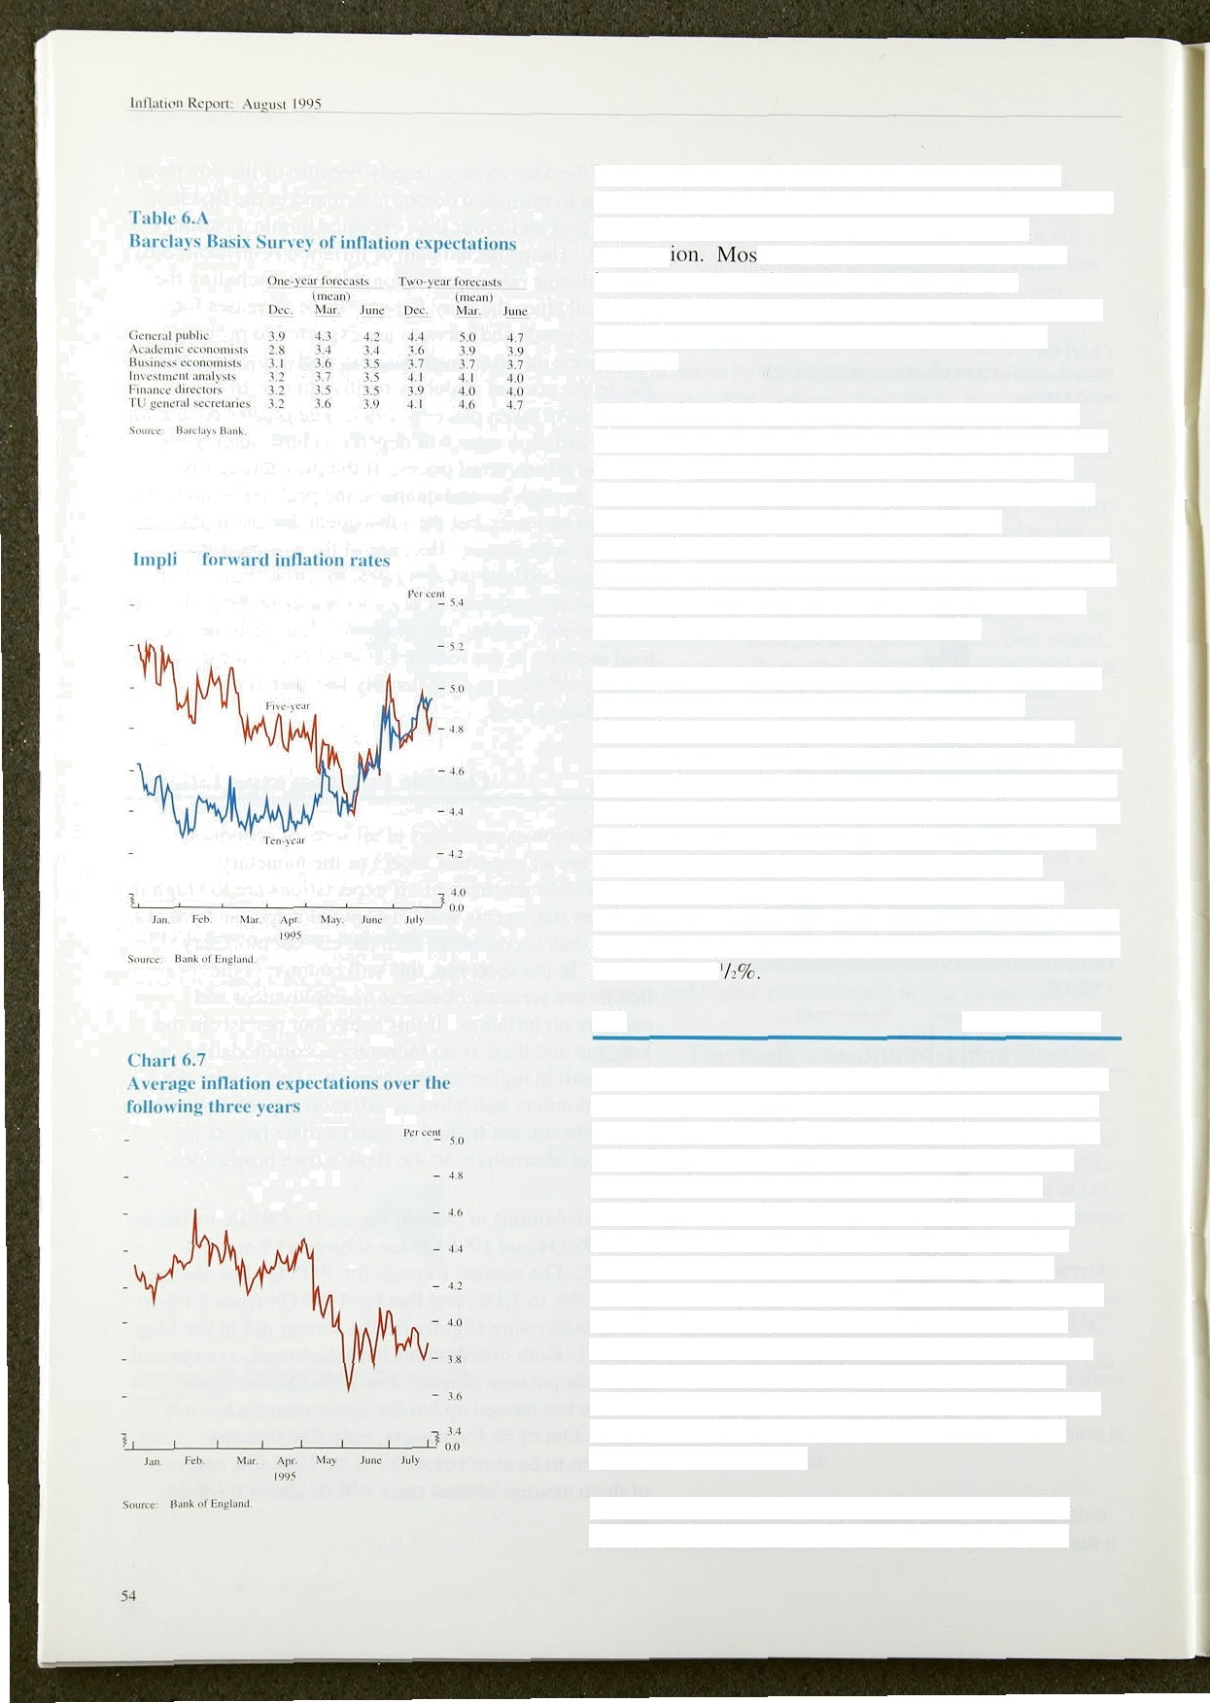

I.”h:irt 6.6

Bank projections have tended to be below those of outside forecasters, despite the fact that the latter are not constrained by the Bank’s constant interest rnte

assumpt t outside forecasters assumed that interest rates would rise. Hence, if the Bank’s projections had been made on the same basis, the Bank would have appeared even more optimistic about inflation.

The Barclays Basix Survey does not show a uniform change rroin its March results for inflation expectations (which had shown upward movements) (Table 6.A).

The Smith New Court/Gallup Fund Managers’ Survey reports no change between April and July in expectations of inflation by the end of 1995 and the end of 1996. The Gallup Consumers’ Survey and the Callup Employees’ Survey both show slight falls in inflation expectations during the past three months.

The expectations of participants in the gilt market have moved around during the past three months, as

Chart 6.6 shows. At the ten-year horizon, they have increased; this may be of limited significance for current price and wage-setting behaviour, but it suggests that the long-term credibility of monetary policy has been eroded a little. At a horizon of five years, there has been little net change. Averaging over the next three years, expectations have dropped (Chart 6.7), reflecting a

re-assessment of the economic conjuncture as well as the stance of policy. But at all horizons, expectations remain in excess of 2

#### 6.5 Conclusions

Underlying twelve-month RPIY inflation has moved up over the past quarter, although some other measures of inflation have fallen. The pattern of a ‘dual economy’, with sharply contrasting fortunes in the tradable and non-tradable sectors, remains marked. Although volatile, net trade has had a positive effect on output growth But domestic demand has been rising at or below its trend rate for some time. Since the May *Report,* there has been a series of weaker than expected statistics for activity in manufacturing, housing and

construction, and the labour market. It was a surprise, therefore, when the national accounts reported that, because of strong growth in the services sector, non-oil output as a whole grew slightly faster in the second quarter than in the first.

But the recent indicators do not alter the underlying prospects for the next two years. A combination of



**Table QB.** fiscai and monetary restraint, and a fall in the real

**Reiatire post-war inflation perfomMBDCfl** exchange rate, has enabled resources to be switched

from domestic consum **tJOTl** to net experts.



PiopoHion o :

'

Lo°»na

Uxited yiagdom

**.Uni‹ed.States**



Chart 6.8

Jan, t948-May 95 .149 479

June r94P—June 95 43,'¥' 3bF

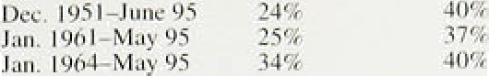

ahead; net trade should continue to benefit from the lower real exchange rate, and consumption and investment are likely to grow at a faster rate. Indeed, if the recent acceleration in broad money were to continue, nominal domestic demand could pick up rapidly.

In his Mansion House speech on 14 June, the Chancellor

of the Exchequer made it clear that the Government’s

Inflation:‹•› United Kingdom‹•› and

**United States**





- - 20







tb) 9rioi in I g7s,'gPl datn are used: sut«›quenii} RPIX dnia cm nd.





InAzC‹m:•› Gern-7andJapen

PccenopcEaugo'npñcrsQnsgo c%h«



- 20

- 0











target for inflation is for the twelve-month rate of increase of RPIX to be at or below 2'/i%. The Government’s target is a demanding one. Inflation has only been 2'/ % or lower about a fifth of the time since the Second World War in this country. Other major countries have a better track record (see Table 6.B and Charts 6.8 .and 6.9). While aiming consistently for 2’/the or less, the Chancellor acknowledged that, because of shocks, inflation would vary, staying within the range of I to—4% most of the time. This, too. is a demanding standard, which even Germany has met only just over half the time (see Table 6.B). lt represents a considerable improvement over the United Kingdom’s past experience. but is attainable with the appropriate monetary policy stance.

The Bank’s central projection for inflation two years

ahead is similar to that in May, although the

pass-through of higher import prices to retail prices is expected to be slightly less rapid because of slower than expected growth in manufacturing output and retail spending. It remains the case that it is more likely than not that RPIX inflation will be above 2'/i9r in the middle of 1997. There are, of course, significant uncertainties about this judgment. On the upside, the risk is that expectations of on accommodation of second-round effects of the fall in the exchange rate—now some 6% since the beginning .of the year—will lead to upward pressure on domestically generated inflation. That is why it is so important that monetary policy is seen to be directed at meeting the inflation target. On the downside, a .reversal of the recent rise in stockbuilding might lead to a slowdown of growth and downward pressure on already .sub‹iued domestic inflation.

#### The dual:nature of the economic recovery makes the dileñiina for mongJaty policy more acute than betore. Time will resolve the puzzles about the strength in

**:aut1vity,!,&ioney growth ând domestic inflation.. But the lags between changes.in monetary policy and**

their impact on inflation mean that decisions must be made before the puzzles are fully resolved. The familiar danger is that delay in taking action could ultimately result in interest rates having to go higher than would otherwise be the case.

